

User Manual of BPM

Document N.: PO-ITPRO-14009

Revision: 0

Date: 20/01/2015

Author:

Abhishek Mishra

For further information please contact:   
  
Name Surname

Job Title

Phone: +39 039 5961605

Mobile: +39 3428060543

[xxx@projectobjects.com](mailto:xxx@projectobjects.com)  
[www.projectobjects.com](http://www.projectobjects.com)

© 2015 Project Objects Ltd

Executive Summary

With the growing technological environment,the need of project management has grown tremendously. Nowadays,managers show interest in management techniques and application that ease their work with perfection.Therefore,Project Objects is trying to cover all the project management methodologies in its application. We are improving and upgrading our application with the help of requirements and researches.

Our latest application release comprises of Business Process Management(BPM). This manual implicates all its functionalities and use. In this manual, we will discuss about the complete BPM process and how it can be usefull to our clients and user.

Table of Content

**Glossary 4**

**Chapter 1**

**Introduction 5-7**

**Chapter 2**

**Business Objects Configuration 8-14**

**Chapter 3**

**Form Builder 15-28**

**Chapter 4**

**Email Notification 29-34**

**Chapter 5**

**Workflows Designer 35-43**

**Chapter 6**

**Workflow Association 44-46**

**Chapter 7**

**Execution of BPM 47-52**

**Chapter 8**

**Version 53-67**

**Chapter 9**

**Version Association with Workflow 68-70**

**Chapter 10**

**Multiple Users in Workflow 71-74**

**Scope for Future Work 75-76**

**Advantages 75-76**

Glossary

**BPM**- Business Process Management

**PO-** Project Objects

Chapter 1

Introduction

* Background
* Objective
* Business Process Management

# Introduction

## Background

Projects Objects has developed PO application, which works around Portfolio and Project Management. Till date, Project Objects have released 7 versions of PO application and is now releasing PO8 with the new features and functionality.

In the older versions of PO application, objects were created on predefined Form and Settings. But in PO8, as per our research and clients requirements, we have given the flexibility to customize the objects such as Form, Properties and Settings according to user’s requirements.

## Objectives

The objective of this manual is to present our new features in latest version of PO application. We will be discussing about the new features i.e. BPM and its functionality. Here in this manual we will be focusing on:

* Business Objects Configuration
* Form Builder
* Email Notification
* Workflows Designer
* Workflow Association

## Business Process Management

Business Process Management (BPM) is a management process that optimizes the business practises. It also enables user to be more efficient, effective and capable of changes in functionality and working scenarios. It does not follow a defined approach; here users can design object’s form according to their need~~s~~ and requirements.

Therefore, PO8 application provides customization for the user. Users don’t have to follow defined process or form. User can make its own process and build forms according to their needs and requirements. Forms can be built for:

* Tickets
* Action
* Issue
* Change
* Document
* Project Request
* Risk
* Project Milestone

To understand better we will take an example. In this manual, we will take Issue objects as an example and understand the entire BPM process.

Chapter 2

Business Objects Configuration

* Creating Library

# Business Objects Configuration

In this section, user can build the library for Form component. User can define components of the Form that can be used at the time of creating the Form. In BPM process, library creation is the very first step that needs to be done. Created library is not company specific; the entire created library will be available for all the organization.

This section will discuss about:

## Creating Library

Follow the below steps to define the libraries in Business Objects Configuration.

1. Click ***Company Settings***



1. Click ***Business Objects Configurstion*** under company settings.

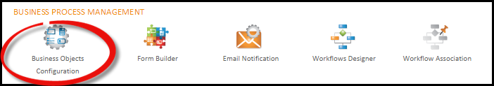

1. First of all, the user needs to define a library to build the form. Library can be defined in Business Objects Configuration. After clicking on Business Objects Configuration, user will be directed to Objects Configuration page where he can define a library which will be used for Form Building.

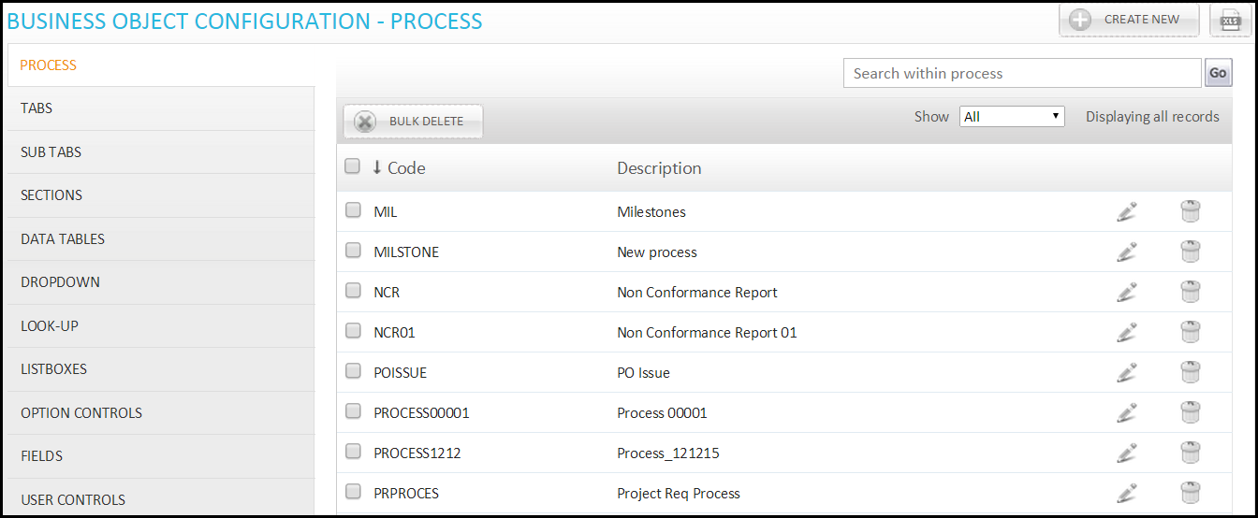

1. Click the ***Process*** tab and create a new process. Fill the required information and click to save. Form can be built with unique combination of process and form type i.e. A combination of one process and one form type is allowed to build only one form.

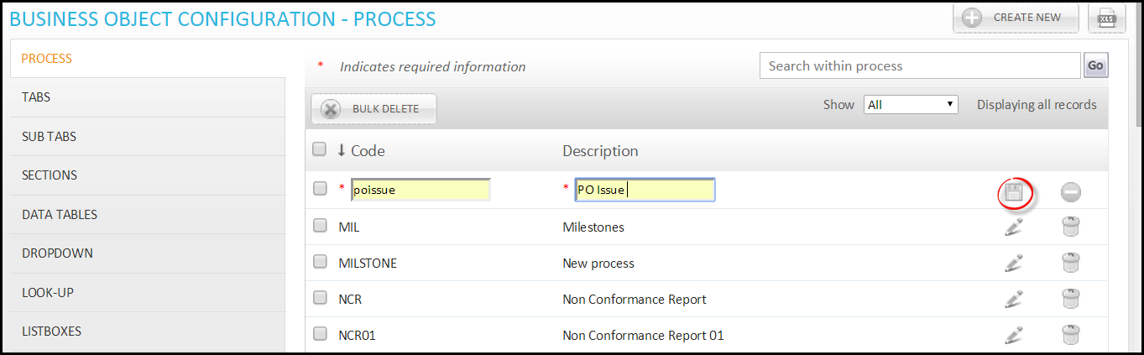

1. Click ***Tabs,*** then click ***Create New*** and fill the required information and click  to save. Similarly ***Sub Tabs*** can also be created.

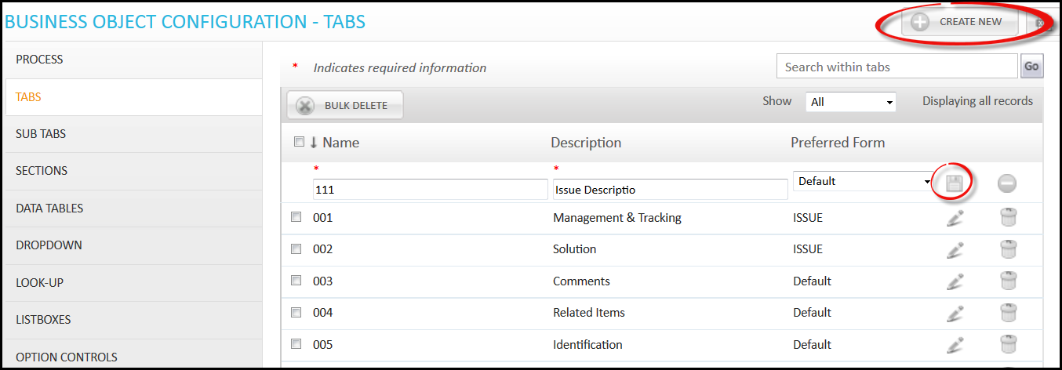

1. Click ***Sections*** and then click Create New, fill the required information and then click  to save. Section created here will be used in the form when we require placing section in our forms.

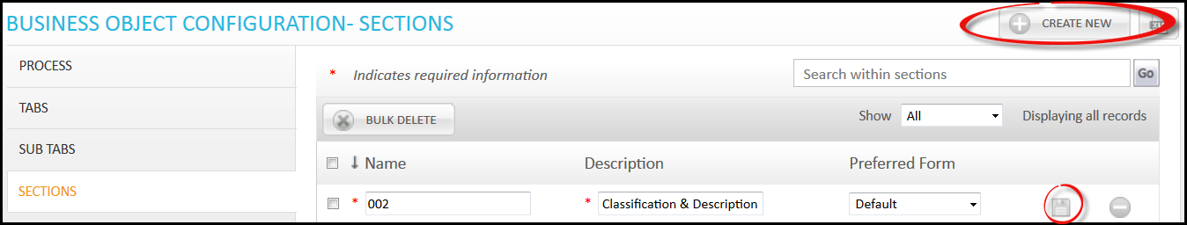

1. Click ***Data Tables*** tab and Create Table name. Click  to define table name.

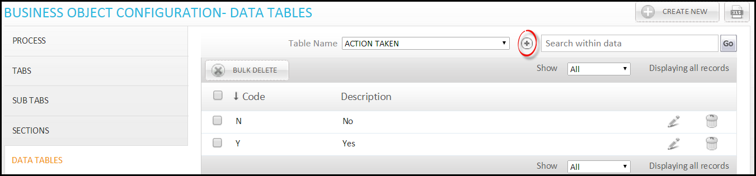

1. You will be directed to Data Tables page. Now click ***Create New*** to create table name. Fill the required information and click. Here, table name will be defined that will be used in form to show the data of table.

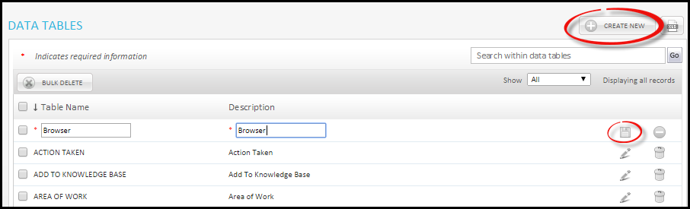

1. Now, enter data in table defined above. Go to Data Tables tab and select Table name for which you want to enter data and then click ***Create New.*** Fill the required information and click. You can enter as many data you want in the table.

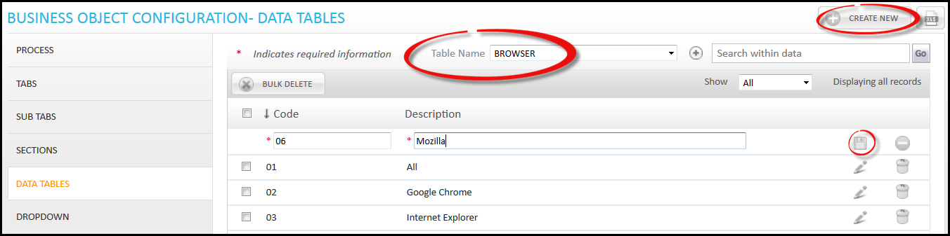

1. Now we will make ***Dropdown*** for Form. These dropdown can be used in building the form. Click Dropdown tab and click ***Create New***. Under Table Name some system defined table will be available by default and the tables which user had created. Even if user has not created any table then also you will get some system defined table here for selection. Fill the required information and click.

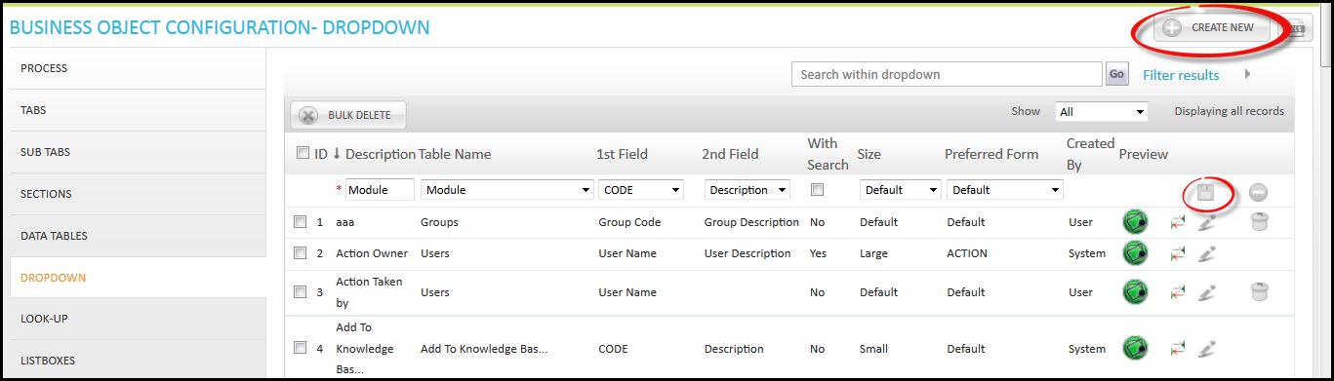

Here ***Preview*** option is given; Dropdown which you have created can be seen here as demo. Click ***Show Preview*** and then a small window will appear showing the preview of created dropdown.

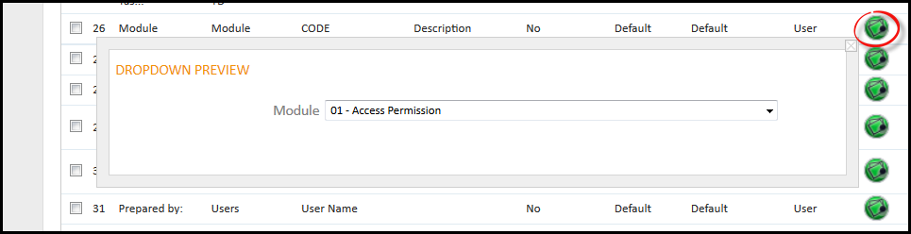

1. After creating Dropdowns, we will create ***Text/Note/Date/Number*** ***Fields*** that will be used in Form building. Click Fields tab and then click ***Create New***. Fill the required information and click.

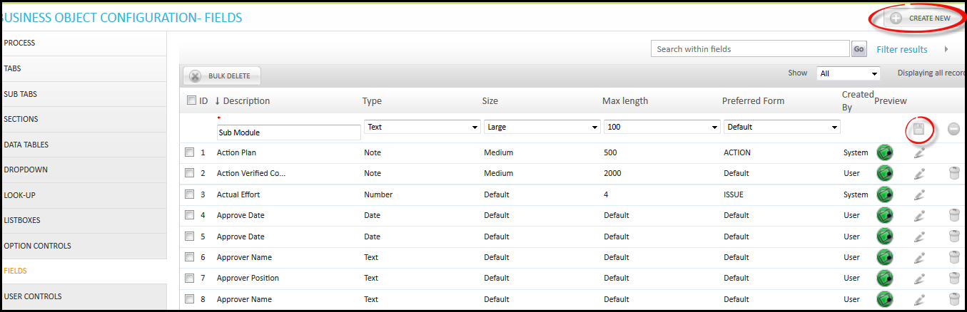

1. There is ***User control*** tab that contains the system defined controls, controls here cannot be deleted but can be edited.

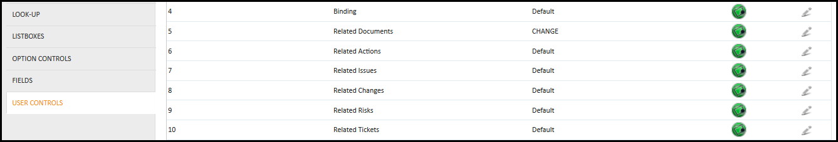

*There are 3 more options available that we have not discussed above since they were not required in the above example. The explanations of these options are as below:-*

***Look-Up*** option is used as a dropdown menu, but data table for this is imported from outside. If you want to use data other than applications data table then we can use these options.

1. Click ***Look-Up*** then click **Create New**. After filling required information clickto save. Here under Connection String, user needs to write the connection string from where data will be fetched. Under Query, user needs to write query for data.

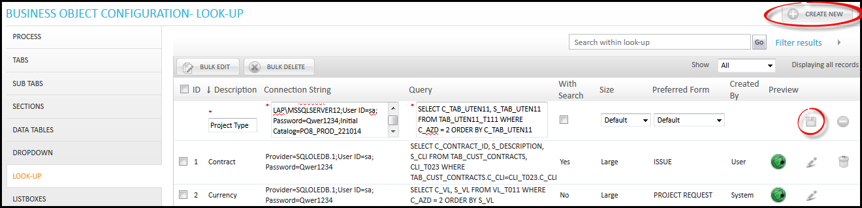

***List Boxes*** option is used to create list box which can be used in the form.

1. Click ***List Boxes*** then click ***Create New***. After filling required information click to save.

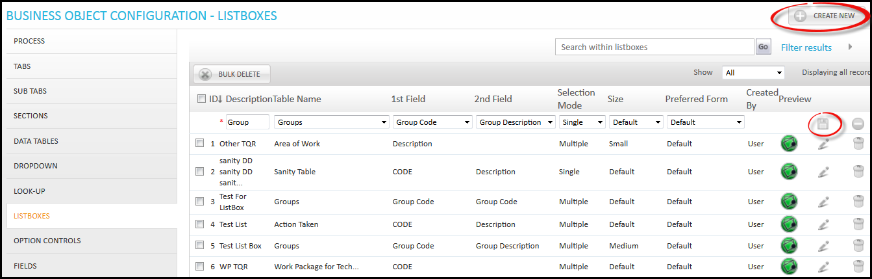

***Option Control*** is used to give options from which user can make a selection. Check box and Radio button is used for options selection~~s~~.

1. Click ***Option Control*** then click ***Create New***. After filling required information click  to save.

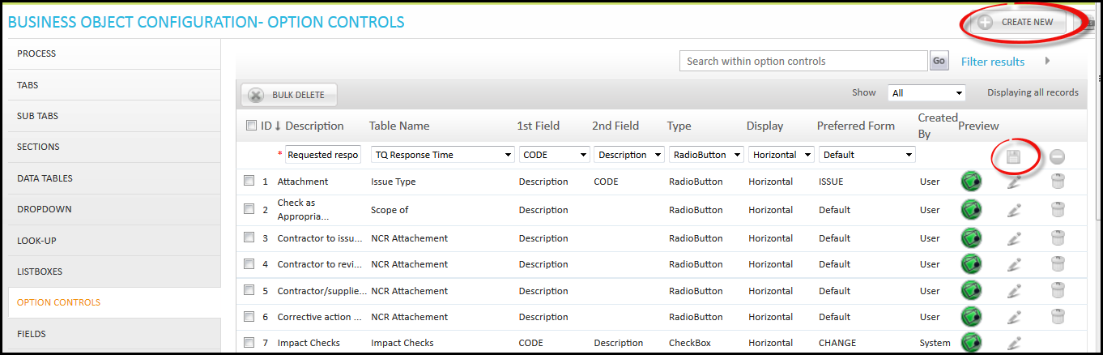

Chapter 3

Form Builder

* Build Form
* Field Configuration
* Email Variables
* Register Fields
* Action
* Process Setting
* Manage Menu

# Form Builder

After creating libraries for the Form component, we will look upon creating the Forms. Since we have already taken an example of Issue object, we will create form using the same example, in order to use it in Team Space. Under this chapter, we will learn how to build forms, different properties and settings of the forms that can be made.

## Build Form

Using libraries that we have created under ***Business Objects Configuration,*** we can build a Form for any objects.

Therefore, follow the below steps to build a form.

1. Click ***Form Builder*** under company settings.

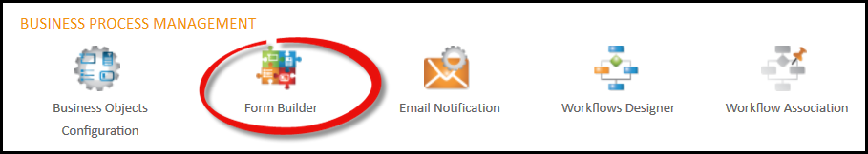

1. You will be directed to Form Register page. To create Form, click ***Build Form***.

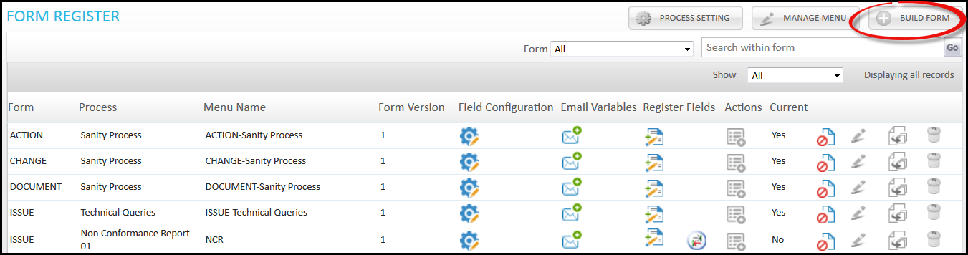

1. You will be directed to Form Builder page; here you can build Form according to your requirement~~s~~. First you have to select ***Form*** and ***Process,*** which has to be a unique combination.

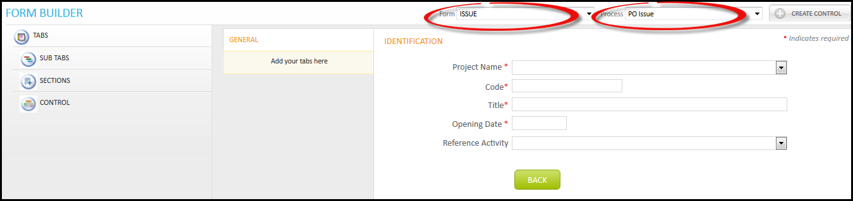

1. Select ***Tab*** which you want to place in your Form and drag it to the tab section. Under this ***Sub Tab*** is also available that can be used like this.

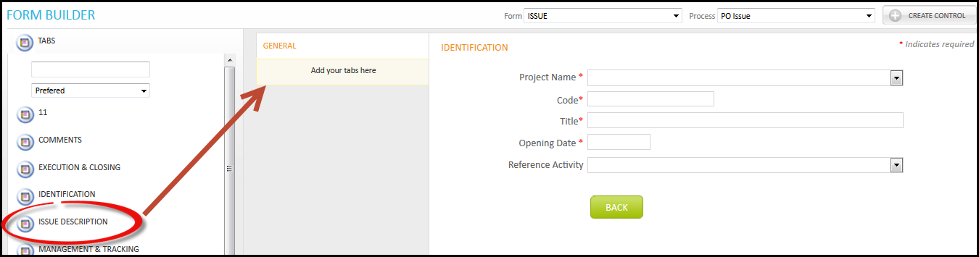

1. Select Tab in Form under which you want to place ***Section***. Now select Sections tab and select particular section and drag it to the Form.

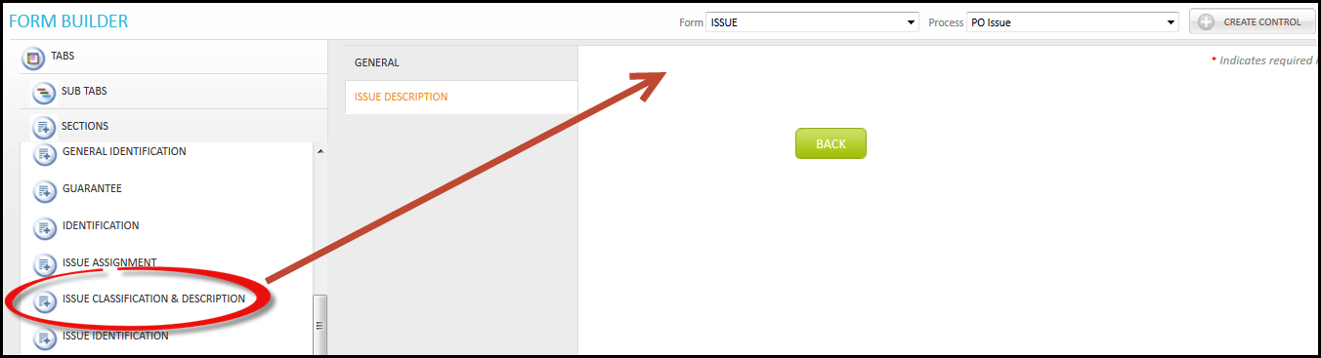

1. Now we will place controls in Form. Select tab, under which you want to place ***Control*** and then select particular control and drag it to form. Under control there are 6 types of control available.

* **Dropdown –** This shows the dropdown list of the data which you have selected under this while creating it.
* **Look-Up –** Used as dropdown only. In this data table is used from outside.
* **List Box –** List box shows the list of data in one list box.
* **Option Control –** This is used for selection in check boxes and radio button.
* **Text Fields –** This is used for entering text/number/date**.**
* **User Control –** Here system defined Control is available that can be used in Form.

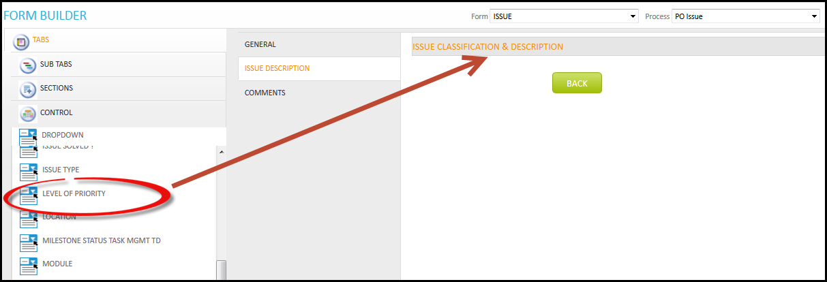

1. In between if you want to make any ***Control,*** you can use ***Create Control*** option available on this page. If you forget to create any control in library then you can create here and this control will be available for you to use. Click ***Create Control***.

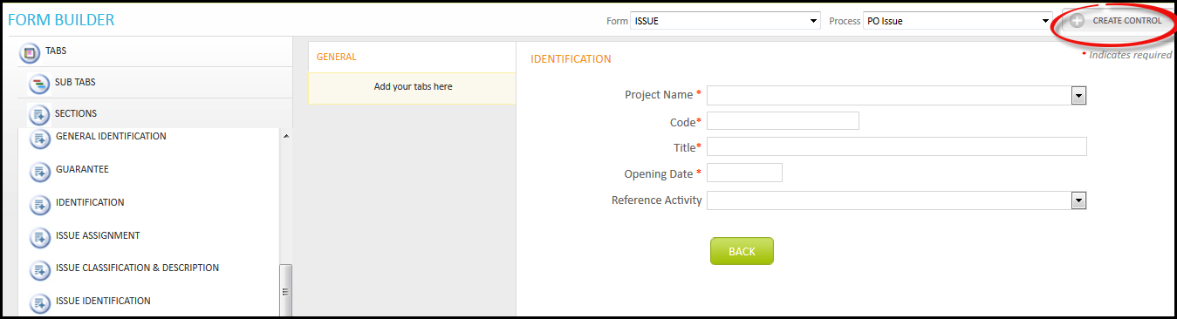

1. You will be directed to Create Control Page, select field and fill required information. Then click ***Save*** to save.

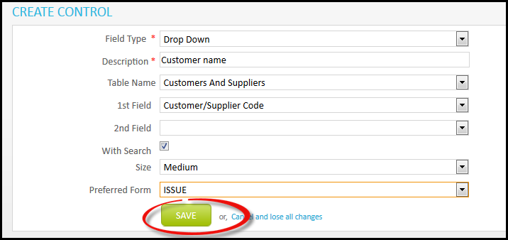

1. A control will be created under the drop down list. This control can be used by a user in the Form.

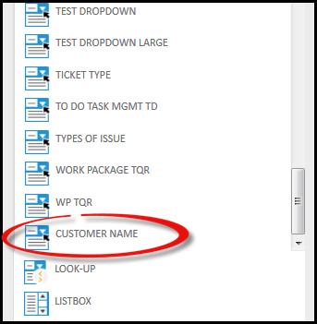

1. After building Form click ***Save This Form*** to save the Form.

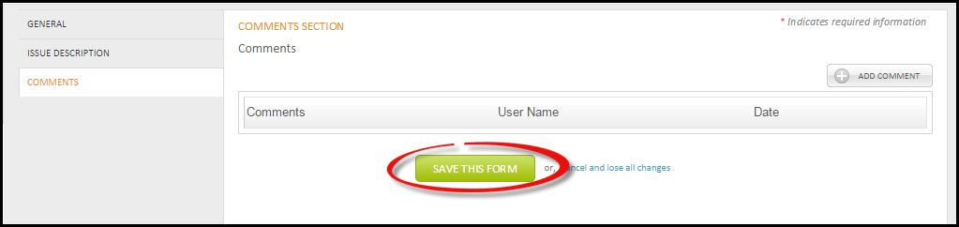

1. A pop up window will appear to confirm your action, click ***Confirm***.

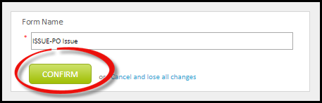

1. A Form is created and is available in list.

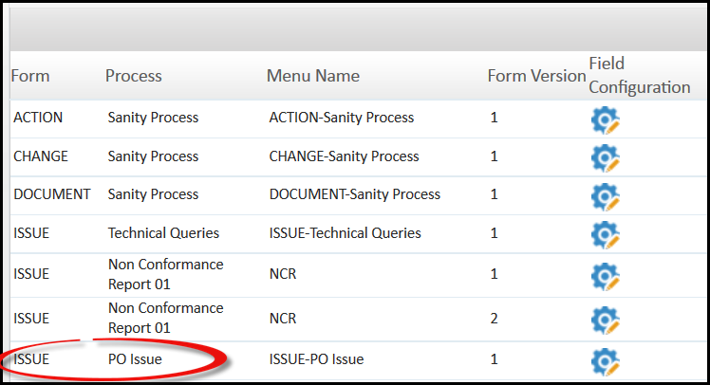

### Field Configuration

Field Configuration is used to define different fields that can be included in a form. You can change the name of field from its standard name.

1. Click ***Field Configuration.***

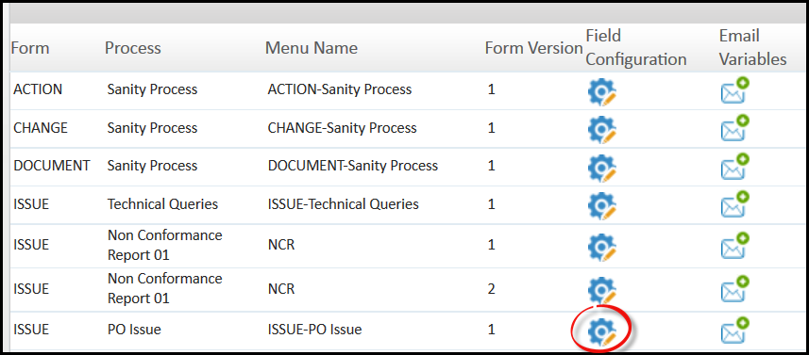

1. You will be directed to Field Configuration page. Here user can edit the name of Field available in particular Form. Click  and make changes, then click 

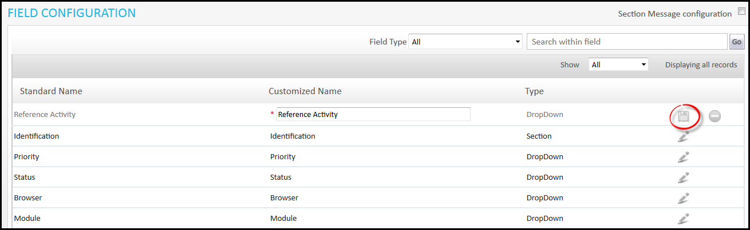

1. On this page ***Section Message Configuration*** option will be available. This option allows user to define message on particular section of the Form, and this message will be displayed on the Form in section area. Check ***Section Message Configuration.***

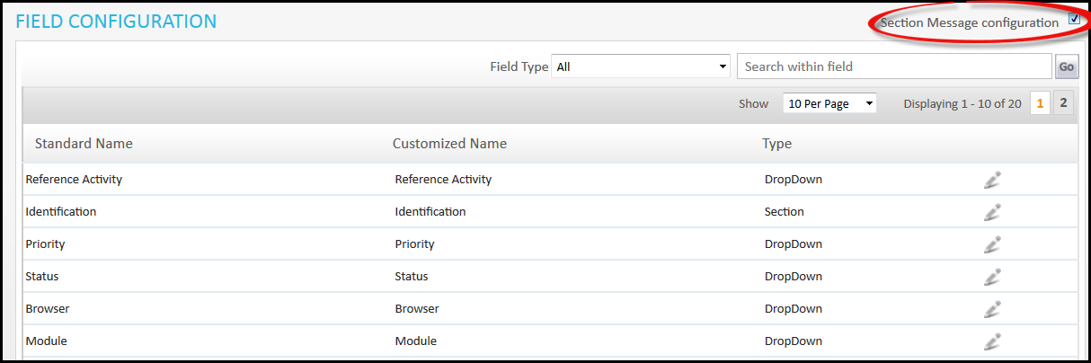

1. You will be directed to Field Configuration page. Here you can select the section and write message. Click ***Apply*** to save dataor ***Save and Close*. *Show*** checkbox is available; if you check only then the message will be displayed on form.

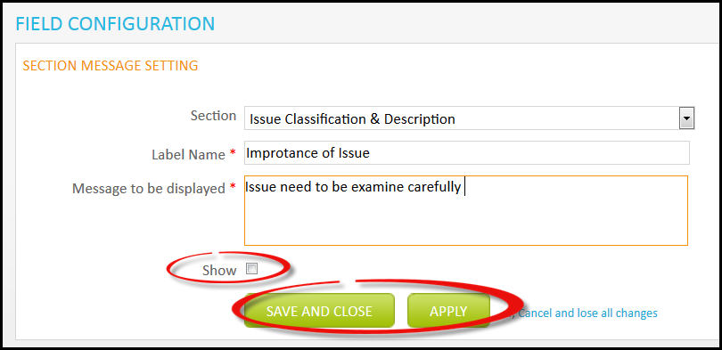

The Message will appear like this on the Form.

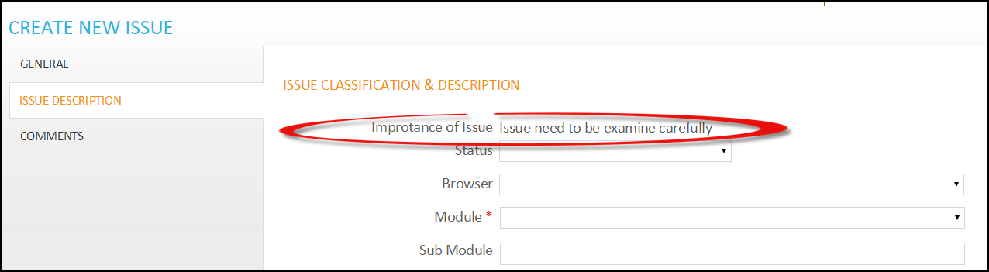

### Email Variables

This is used to define the Variables that can be used in any email. These variables will be available while sending an email and can be used in messages for references.

1. Click ***Email Variable.***

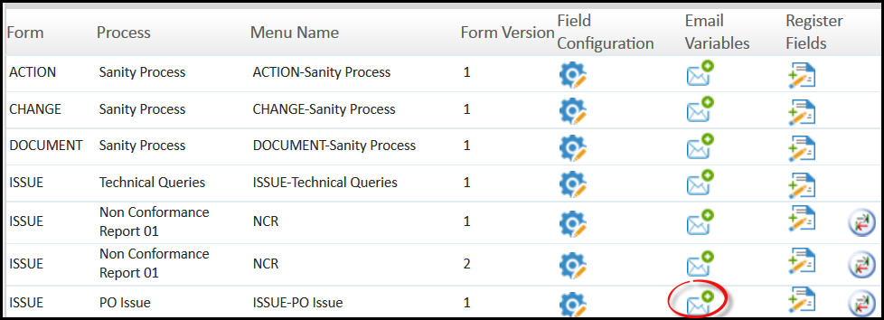

1. You will be directed to Email Variable page, where you can select variables from the available fields that will be used in Email and then click ***Apply*** to save data and continue working or ***Save*** to save and close. Variable that will be available for selections are dropdown, text, date or number from form.

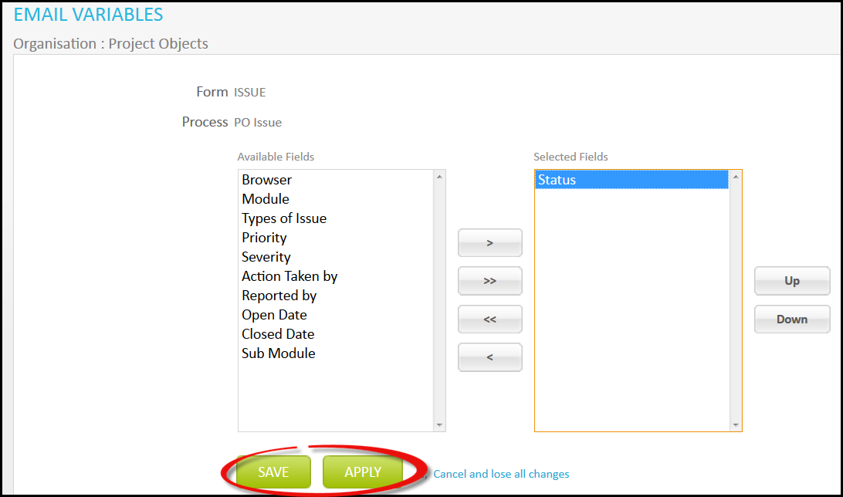

### Register Fields

Here user can define the Fields that will appear as heading on listing page of issues (“POIssue” that we have created, under Team Space)

* 1. Click ***Register Fields***.

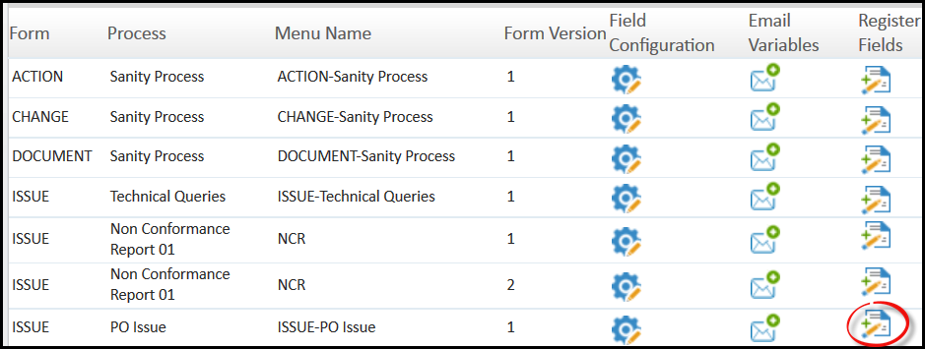

* 1. You will be directed to Register Fields; here you can select the fields. Then click ***Apply*** to save data and continue working or ***Save*** to save and close.

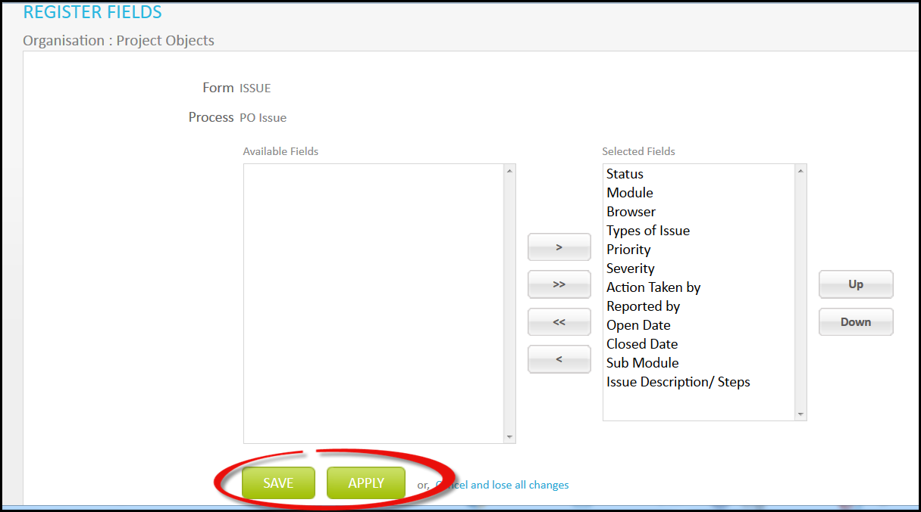

### Action

Here you can define the mandatory fields and fields those will be available for bulk edit.

1. Click ***Actions***.

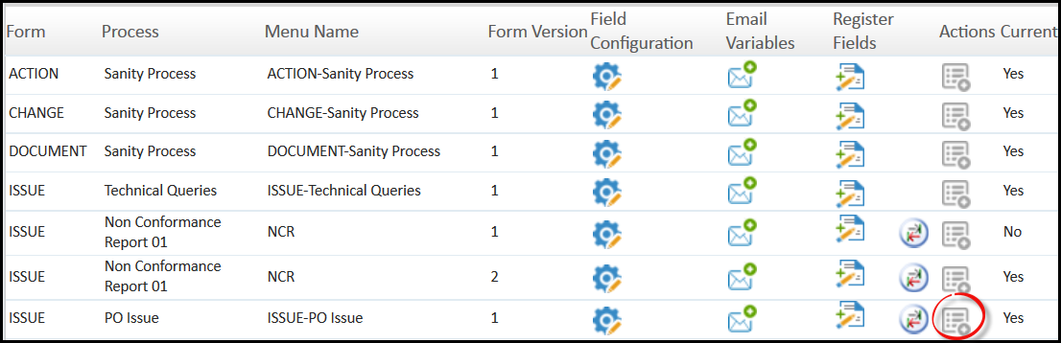

1. You will be directed to Customize Association page where you can define the properties. Mandatory field cannot be selected as bulk edit. Then click ***Apply*** to save data and continue working or ***Save*** to save and close.

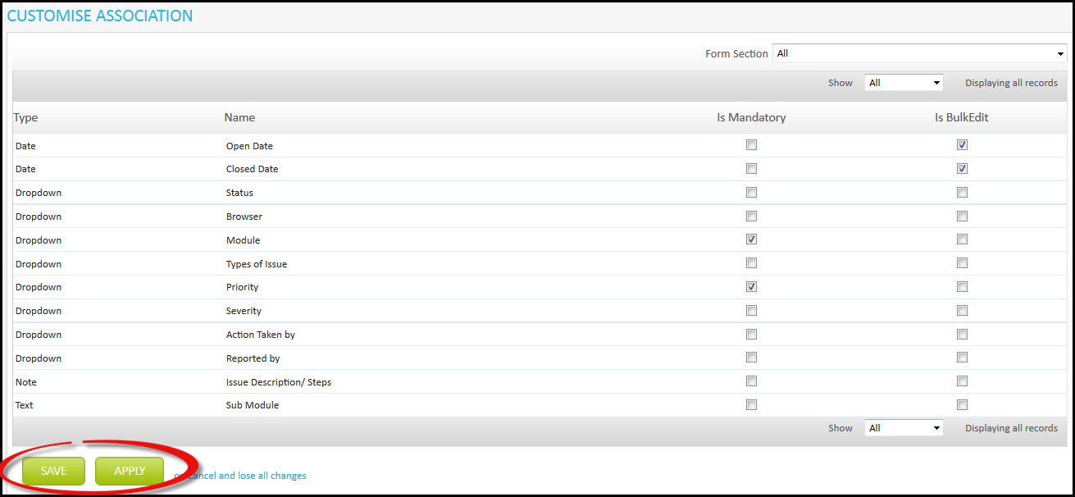

### Process Settings

If there is more than one form version, then user need to select one form from available list as current. User is allowed to create object only on current form, but can work on other forms as well. Therefore, to select current form for the application user can select from here.

1. Select ***Process Setting.***

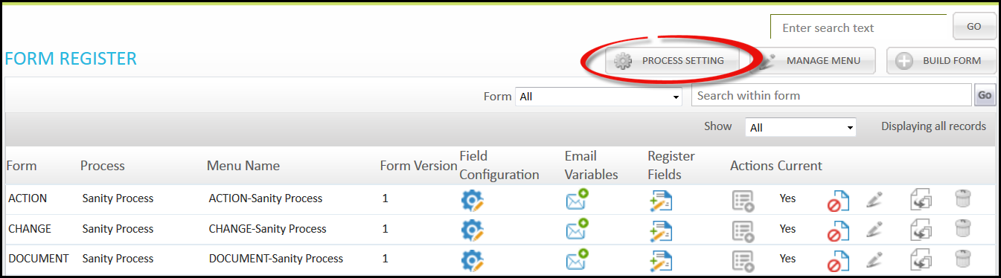

1. You will be directed to Process Setting page, here you can select the Process which you want to make as current. Click, check under current column and click.

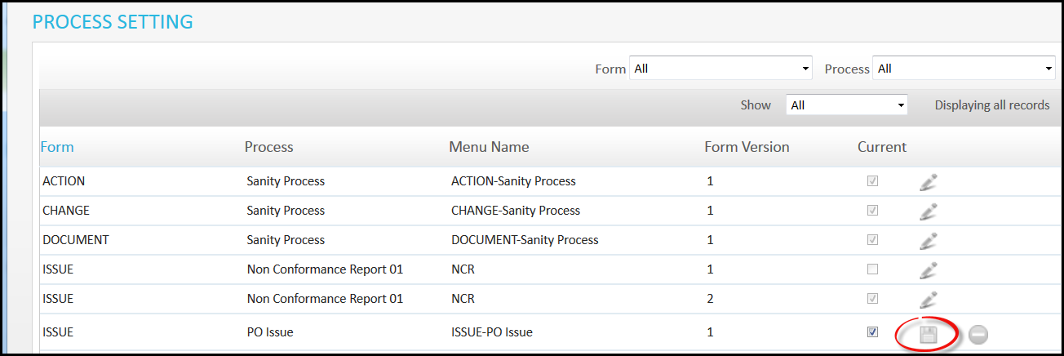

### Manage Menu

Here the user can change the name of his Form that he has created previously. This name will be shown under Team Space.

1. Click ***Manage Menu.***

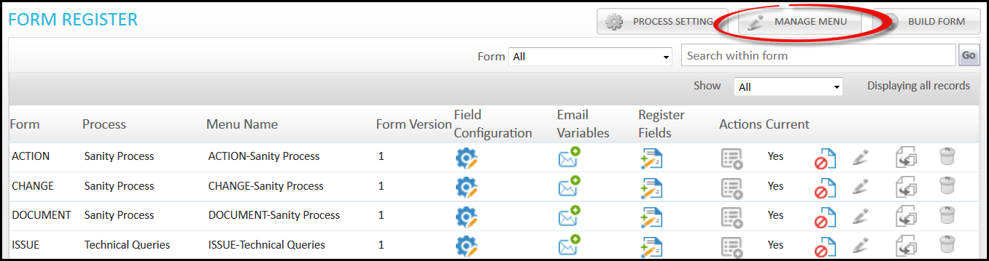

1. You will be directed to Manage Menu page; here you can change the name of your Form. Click, change the name and click.

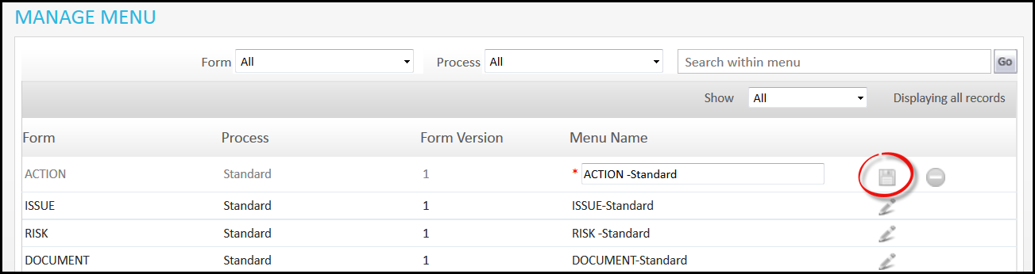

Chapter 4

Email Notification

* Create New Email Notification
* Email Log

# Email Notification

Under this chapter, user can define the Email Notification which will be delivered to the defined users.

## Create New Email Notification

Follow below steps to perform this.

1. Click ***Email Notification*** under company setting.

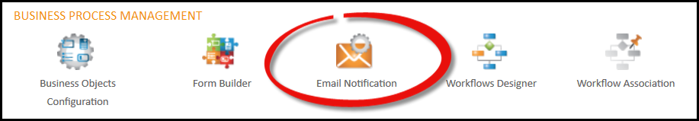

1. You will be directed to Email Notification page. Here you can create new Email Notification. Click ***Create New***.

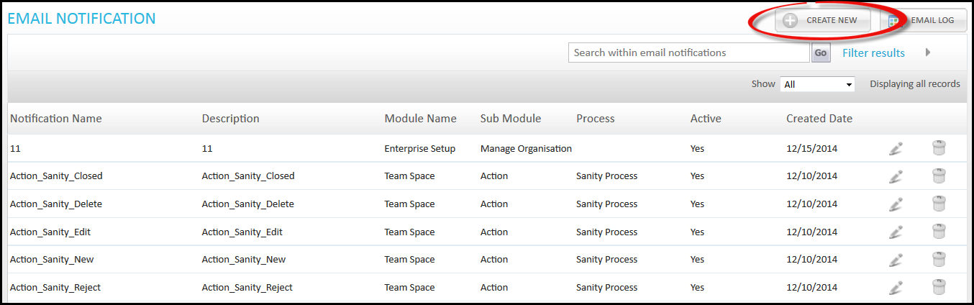

1. You will be directed to Create Email Notification page. Fill the required information. Under **Notification** tab user can define the module, sub module, process and events for which this particular Email is created. User can create as many Email notifications for same event.

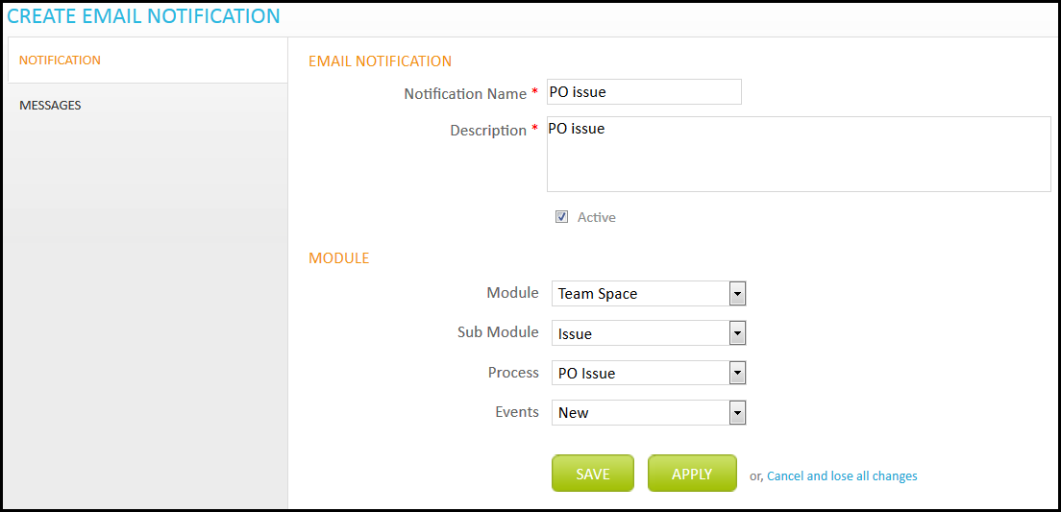

Under **Messages** tab user can define the message that has to be delivered to the defined user. Here you will see some variable that can be used in message. As we can see “Status” variable is also available which we selected under Email Variable in the Form Builder above. These variables will automatically change their name accordingly, like [Project Name] will be changed to real project name for which mail is being used. At last click ***Apply*** to save data or ***Save*** to save and close.

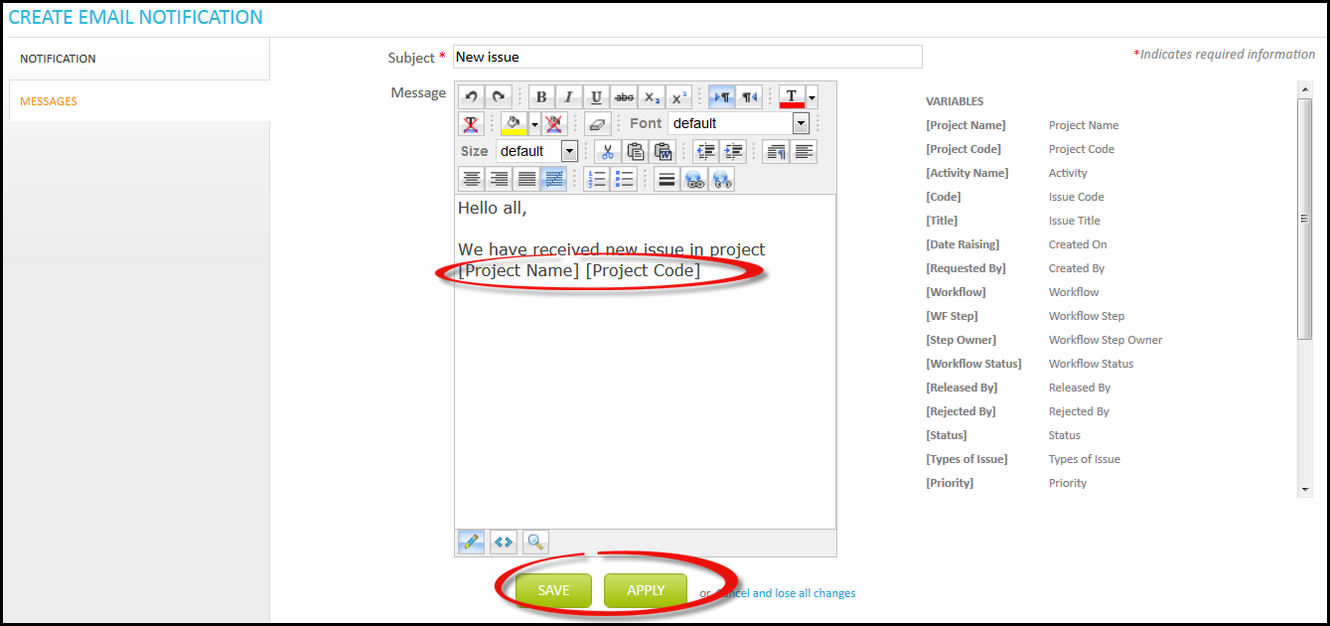

## Email Log

Email log shows the log of emails involved in application. It is a kind of storage of emails information.

Follow below steps to understand Email Log

1. Click ***Email Log.***

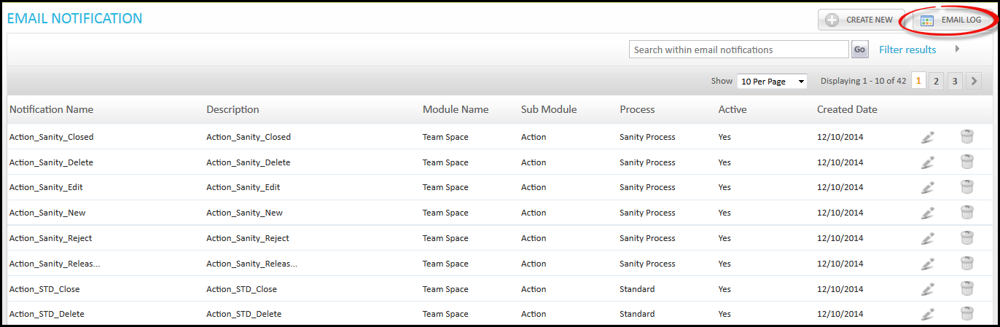

1. You will be directed to Email Log page, where you will find all the details of Emails.

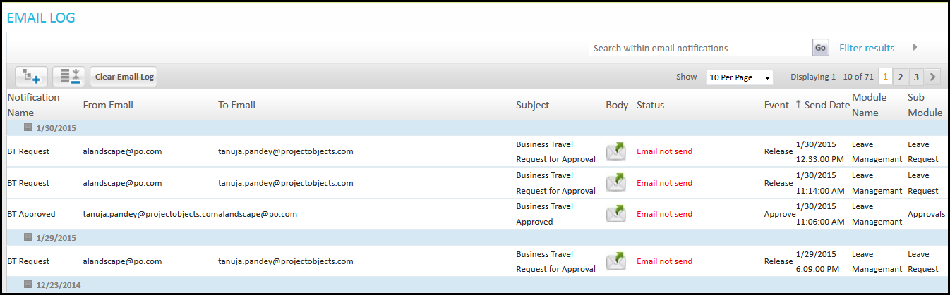

### Email Details

User can see the details of Email. If anytime user wants to see the details or message under Emails, he can see it from here (Email Log). Follow below steps to see Email details.

1. Click ***View Message*** under body column.

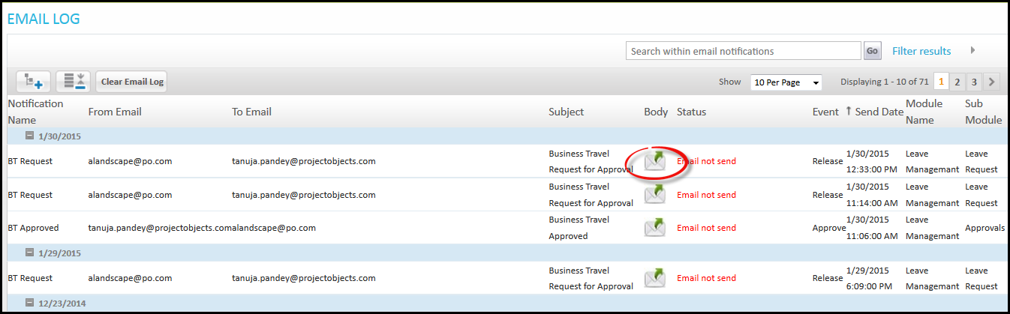

1. Email message for this email will be shown.

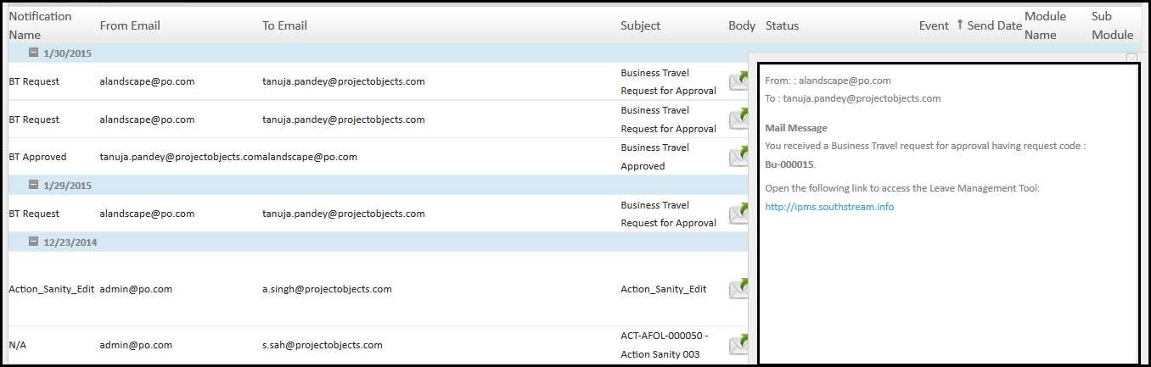

### Clear Email Log

User can clear all log of Emails with the help of Clear Email Log option available. This will delete the log details available here. Follow below steps to perform this.

1. Click ***Clear Email Log***

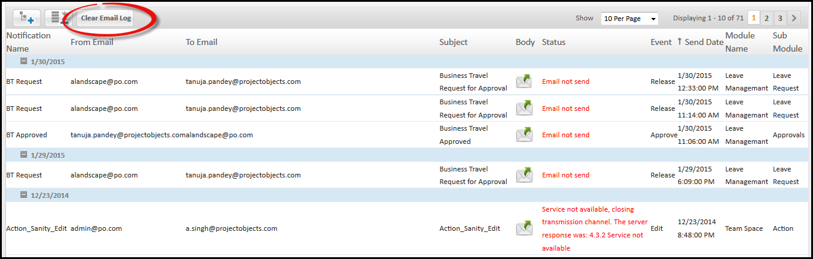

1. A small window will appear asking date, then click ***Update.***

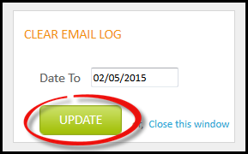

1. Log will be cleared.

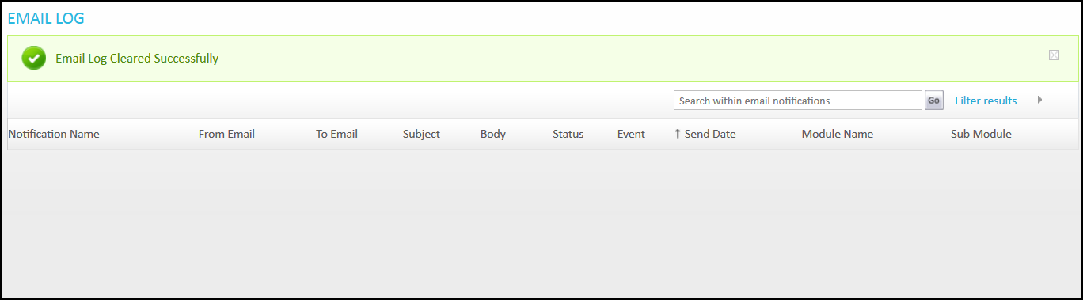

Chapter 5

Workflow Design

* Create Workflow
* Form Section
* Associated Projects
* Advance Options

# Workflow Designer

Now we will create workflow for the Form which we have created above. In this section we are mentioning following features.

## Create Workflow

For this we have to follow below steps.

1. Click ***Workflow Designer*** under company settings.

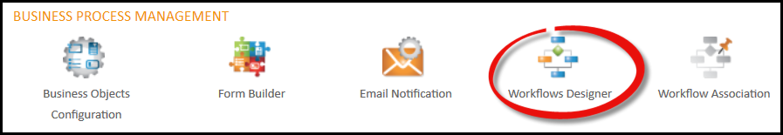

1. You will be directed to Workflow Management page. Select Workflow type and Process for which you want to create Workflow.

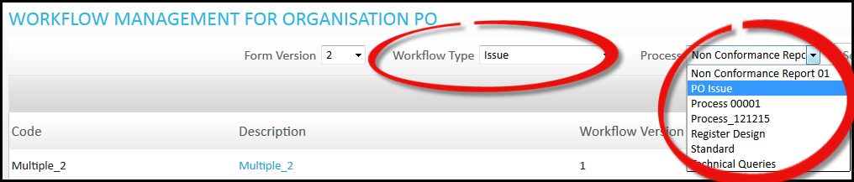

1. Click ***Create New.***

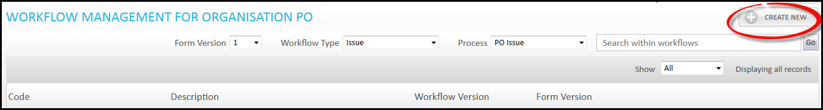

1. You will be directed to Workflow page, fill the required information.

Under **General** section you need to fill general information for the workflow. Option is available, this is used when the initiator of workflow is an outsider from the organization and this initiator does not want to be seen by other external initiator. This option helps only when First step owner is multiple, so that users available in multiple will not be able to know each other’s involvement.

**Process manager** field available here is used to define the manager for process, who will be having full control on this particular Workflow.

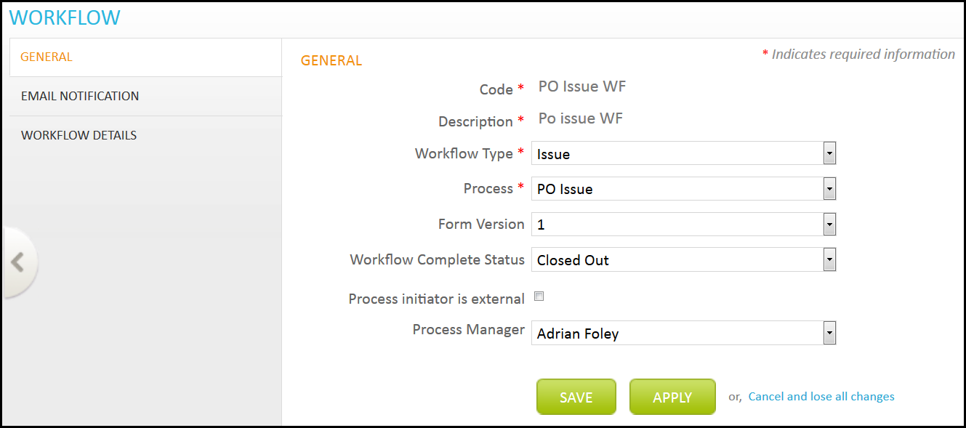

Under **Email Notification,** you will see the different fields for which you want to send notification to the step owner. Under Email Notification, we have created Email for the new issue. If new issue is created, then notification will be sent accordingly. After selection click ***Apply*** to save data and continue.

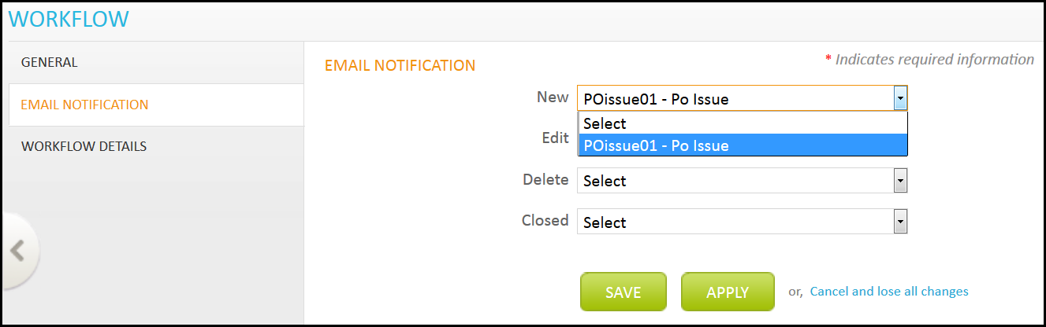

After clicking apply, will appear to select recipient for the Email Notification. Click, you will be directed to Workflow Email Settings page; here you can select the recipient for the Email. Then click ***Apply*** to save data and continue or ***Save*** to save and close.

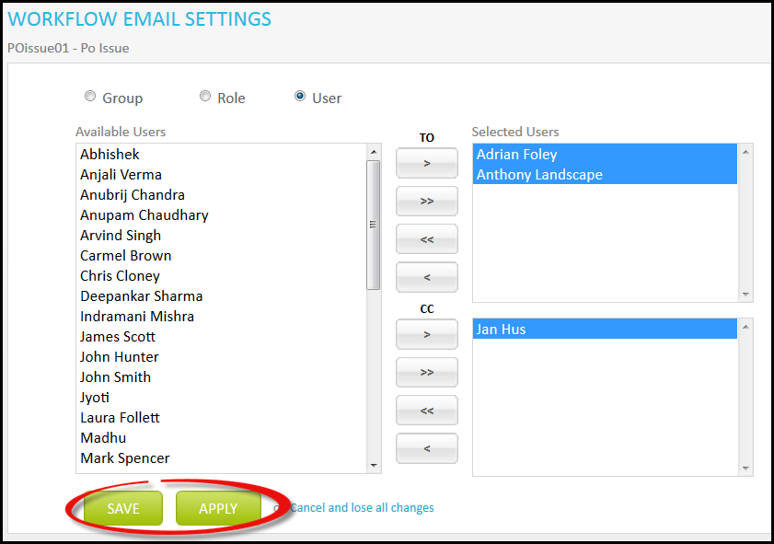

Under **Workflow Details** section, you can define the steps for the Workflow. Click ***Insert New Step*** and fill the required information. Then click ***Apply***.

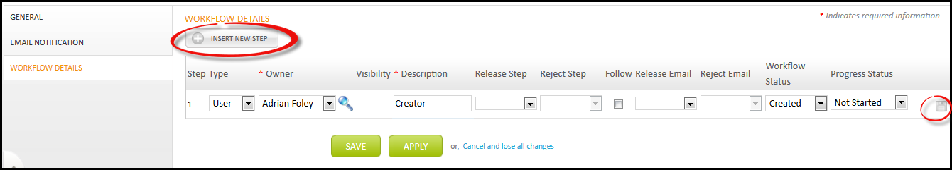

Four new functions will be available now, to define the properties of workflow.

* Form Section
* Associated Projects
* Advance Options
* Follow

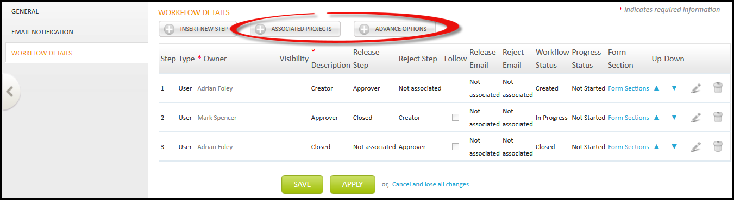

### Form Section

Here, user can state the visibility of sections that should be visible to step owner. A Section of the Form will be available in the list and user can select sections from the list which he wants to make visible for step owners.

Follow below steps to understand this in a better way.

1. Click ***Form Section***

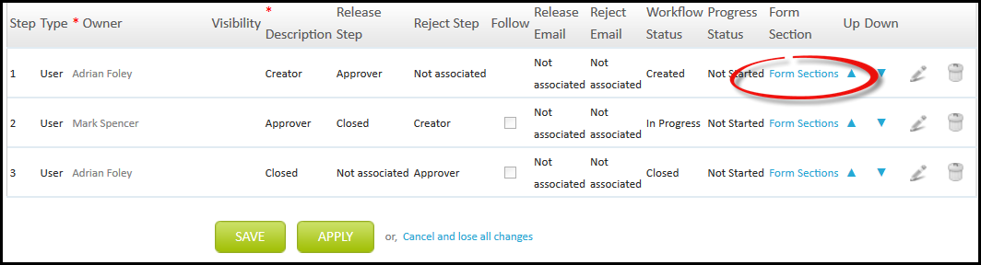

1. You will be directed to Form Sections page, select sections which you want to be seen by step owner. Then click ***Save and Close***.

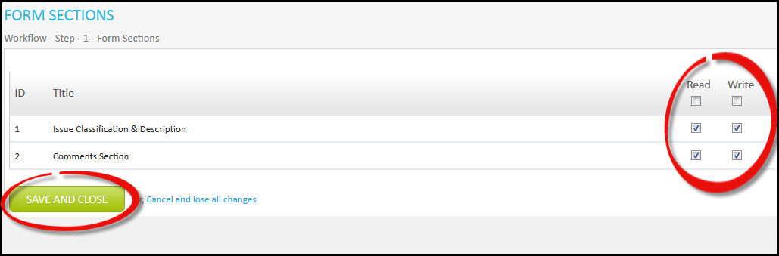

### Associated Projects

Here you can select the projects for which this workflow will be associated with.

Follow below steps to perform this.

1. Click ***Associated Projects.***

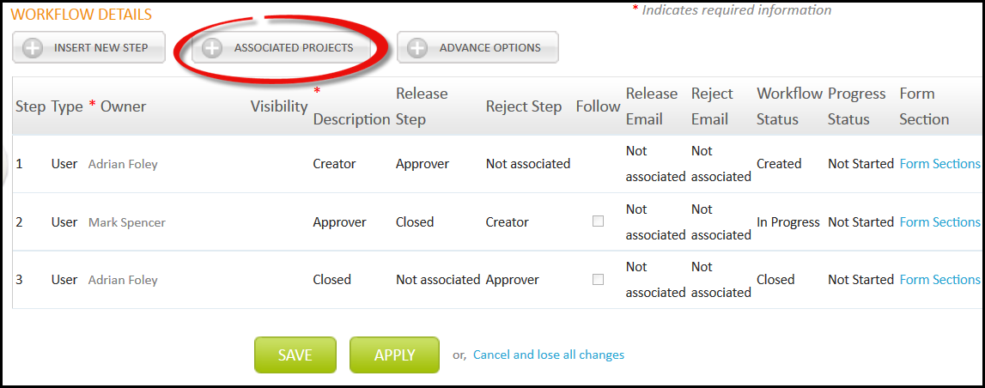

1. You will be directed to Project association page select the Associate Projects and click ***Save and Close***.

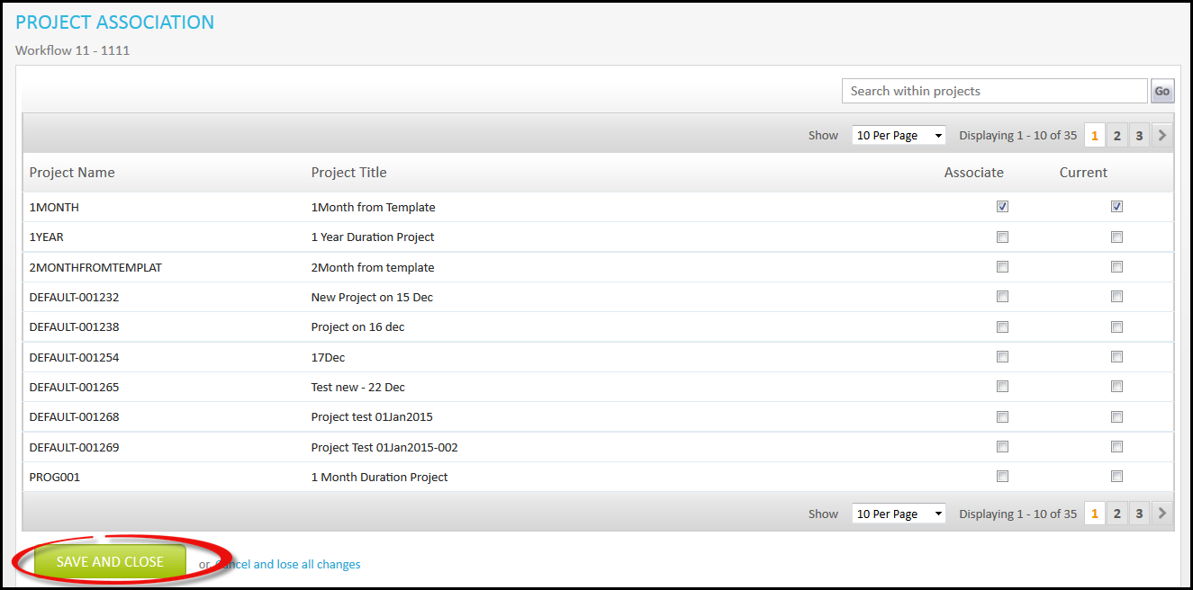

### Advance Options

1. Click ***Advance Option.***

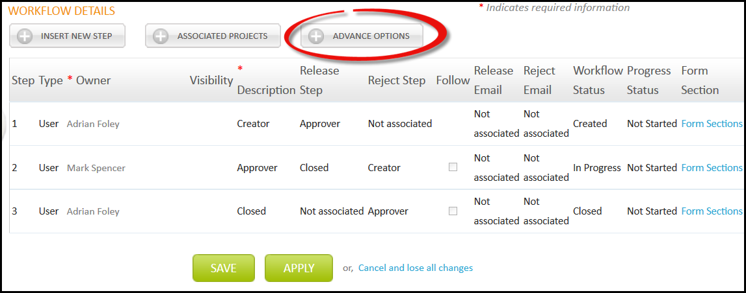

1. You will be directed to Advance Options page; here different options are available for step owner. User can define any options for step owner.

* **Enable Close** option will permit step owner to close the process.
* **Enable Skip** option allow step owner to skip the step.
* **Enable Delete** option will permit step owner to delete the Process.
* **Hide Activity,** this step owner will not be able to see the activity.

After defining options, click ***Apply*** to save data or ***Save*** to save and close.

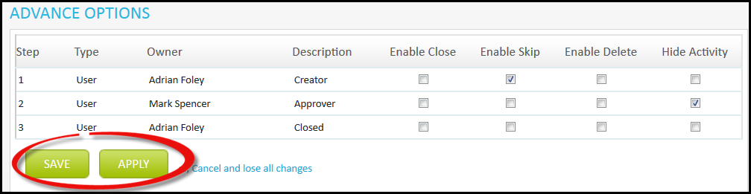

### follow

Follow option is used to make the step manadatory to be followed during workflow. With this function user cannot skip this particular step and need to be followed always.

Follow the below steps to define this.

1. Click 

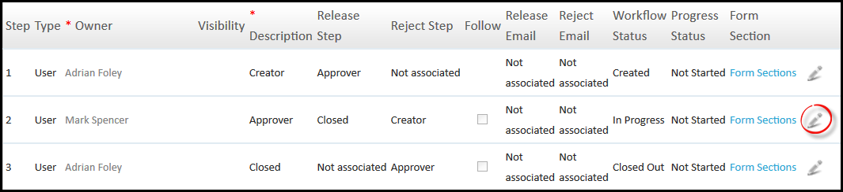

1. Tick the Checkbox under Follow for the step you want to be mandatorily followed. Then Click to save.

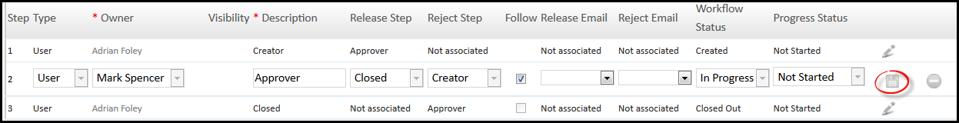

1. Click ***Apply*** to save and continue working or ***Save*** to save and close.

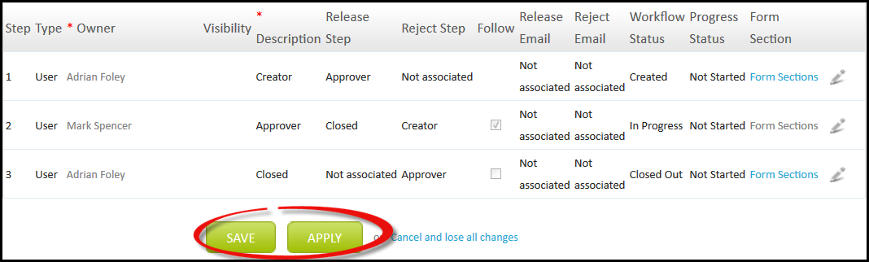

Chapter 6

Workflow Association

# Workflow Association

Here user can associate workflow with projects. Follow below steps to perform this.

1. Click ***Workflow Association***.

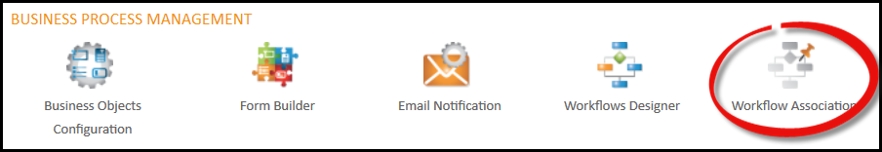

1. You will be directed to Workflow Association page. Select Workflow Type and Process and click  adjacent to project for which you want to define Workflow.

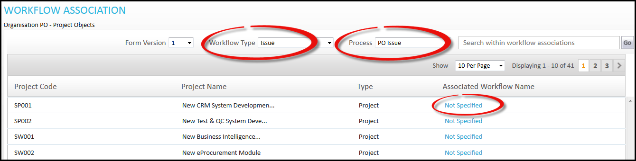

1. You will be directed to Workflow Setting page; here you can associate workflow for project and click to save.

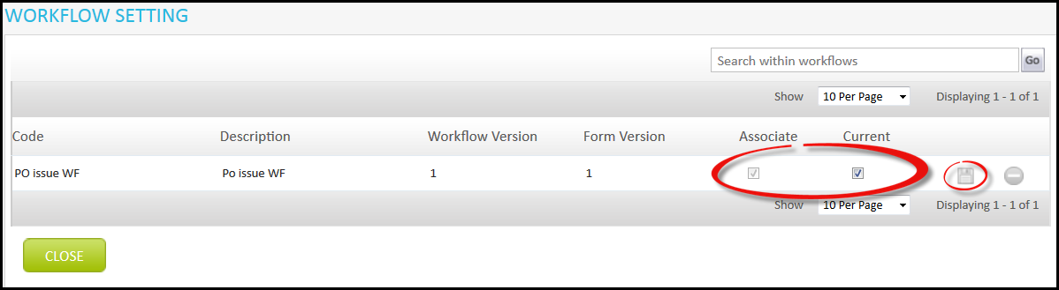

Chapter 7

Execution of BPM

* Executing Created Process

# Execution Of BPM

We have completed the process of BPM formation, now we will start looking on the execution of process. Here, only the step owner can see the process. Therefore, the creator first needs to login and work accordingly.

1. After log in, click  , and then click ***My Preference***.

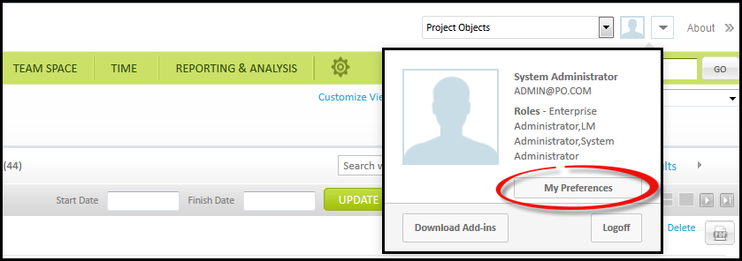

1. You will be directed to My Preference page, under Team Space Menu tab select the process which you have created above and click ***Save.***

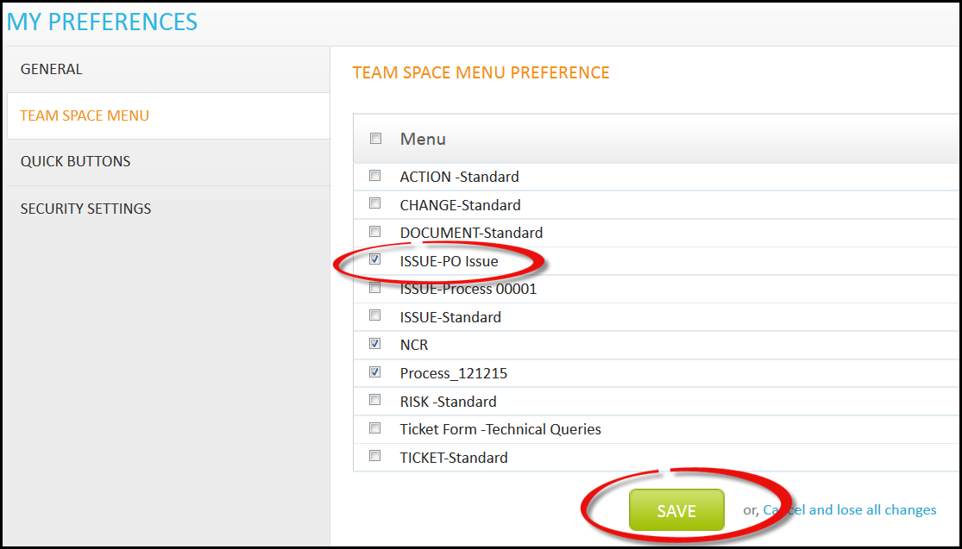

1. Now this Issue process will be available in Team space menu.

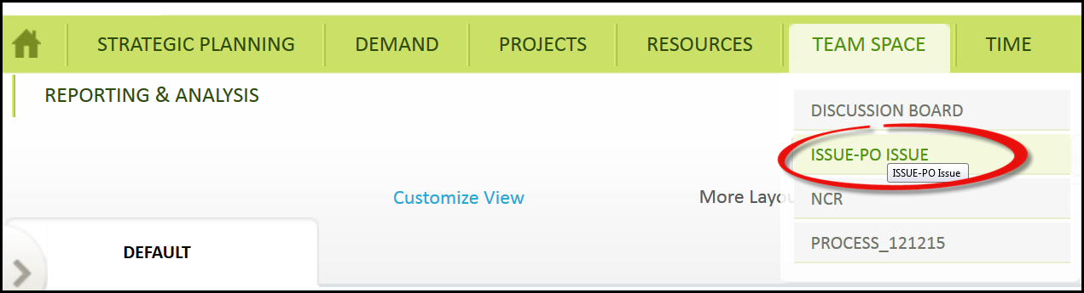

## Executing Created Process

Follow the below steps to perform this.

1. Select Issue process from Team Space menu.



1. You will be directed to “ISSUE-PO ISSUE” page, Click ***Create New.***

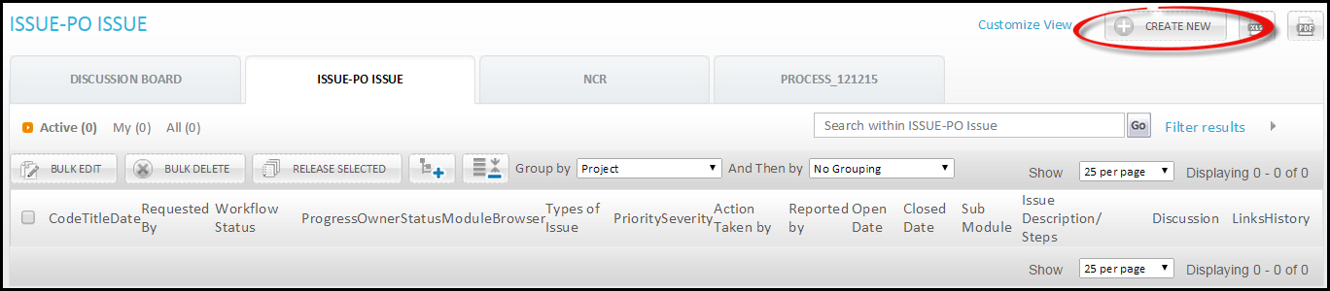

1. You will be directed to Create New Issue page; here you can see the form that we have created above in form builder. Fill the required information.

**General** tab requires general information on issue. Here ***Reference Activity*** will be shown as this owner has permission to see this field (under Advance Option).

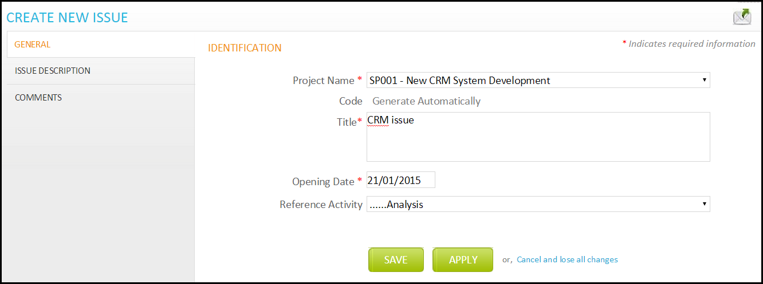

**Issue Description** requires information on issue.

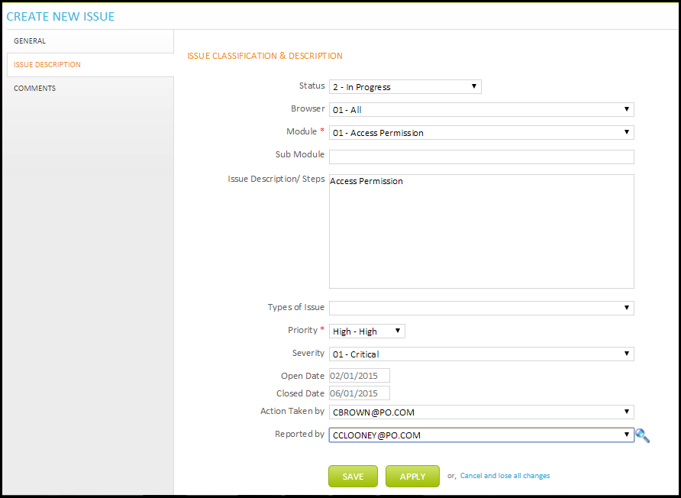

**Comments** section is used to give comments related to this issue.

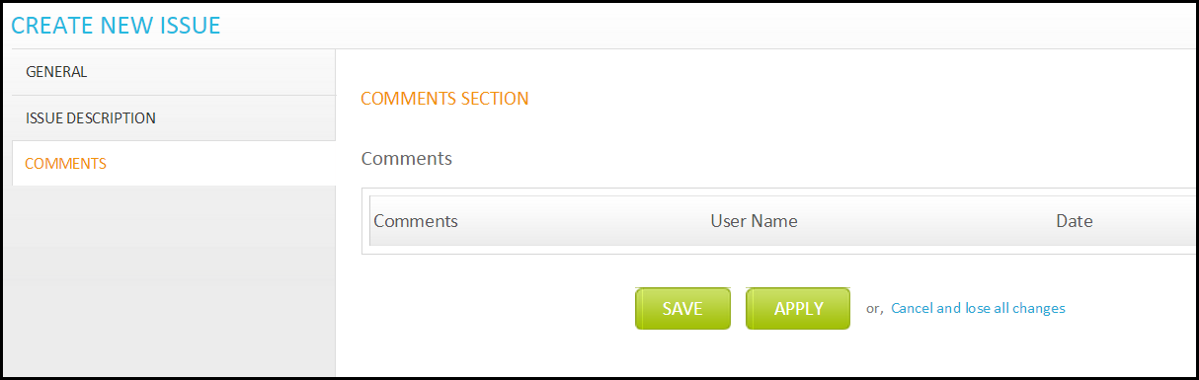

1. Click ***Apply*** to save data or ***Save*** to save and close.

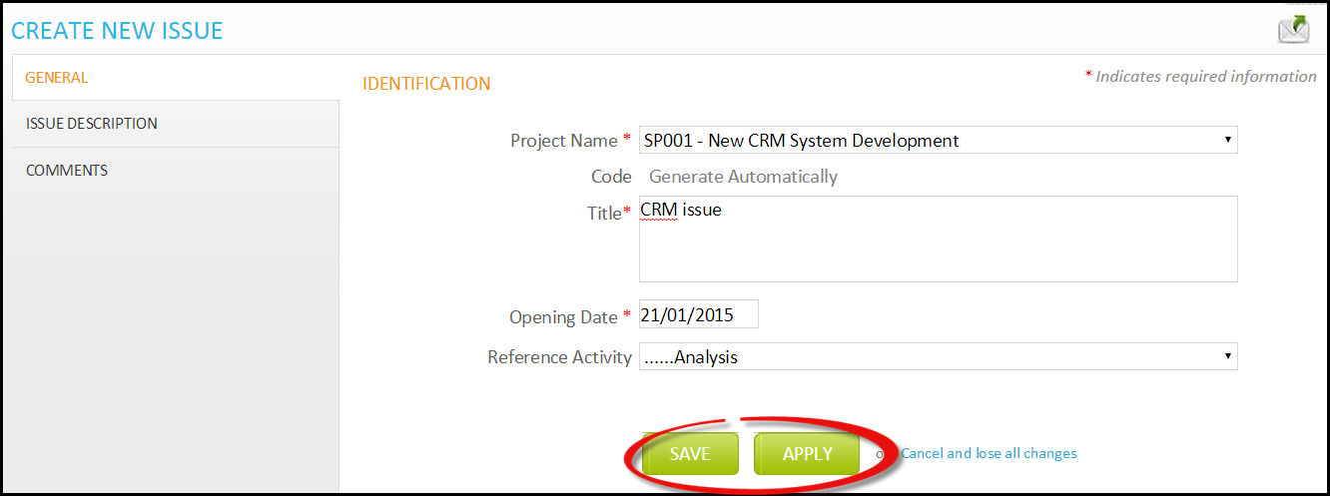

1. A new issue object is created.

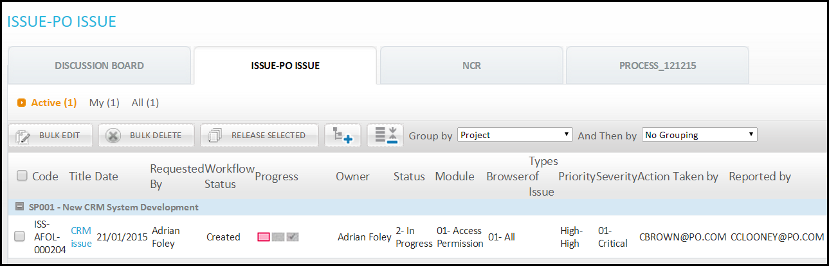

1. To release issue, select issue and click ***Release Selected***. Selected issue will be released to the second step’s owner.

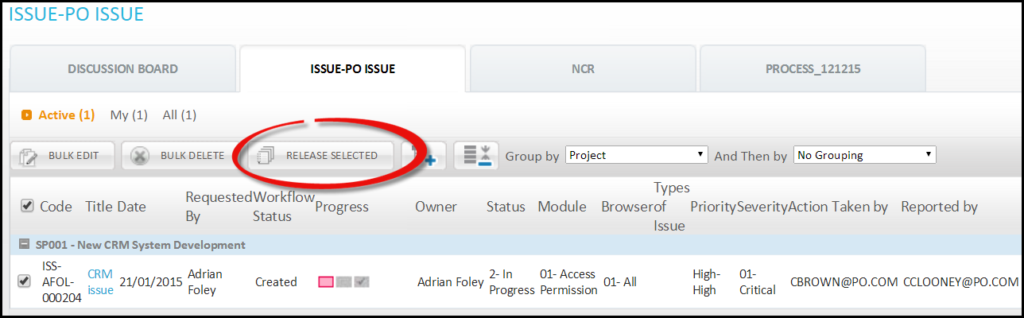

1. You can see progress of workflow under Progress column.

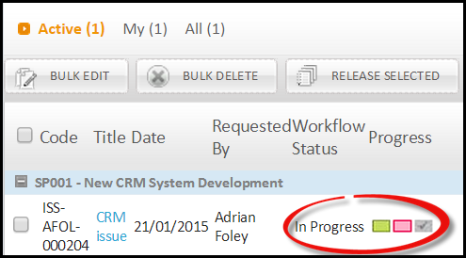

Chapter 8

Version

* Form Version
  + Creating Form Version
  + Field Configuration for Version
  + Email Variables for Version
  + Register Fields for Version
    - Add Fields for Register
    - Add Fields for Single Register
  + Action for Version
  + Process Setting for Version
  + Process Settings
  + Manage Menu for Version
* Workflow Version
  + Create Workflow Version

# Version

Version is created to make different copy/version for anything.

## Form Version

Form version is used to make version for existing form. Different Form can be created with the same Form format. The version created does not copy the settings and properties of existing form, it only copies the Form format and saves it as a version. Form version can be created only after object is created on first version.

### Creating Form Version

To create form follow below steps.

1. Click ***Form Builder***

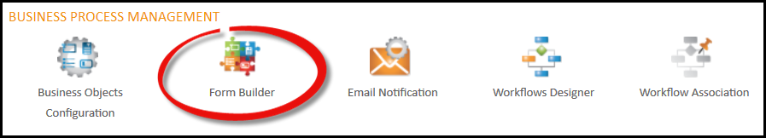

1. You will be directed to Form register page. Click Form Version.

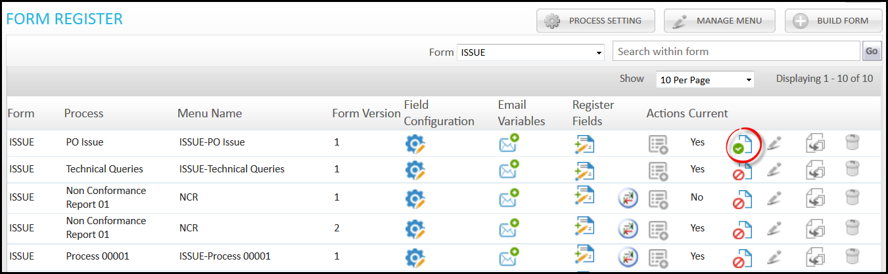

1. You will be directed to Form Builder page, make the changes and click ***Save This Form.***

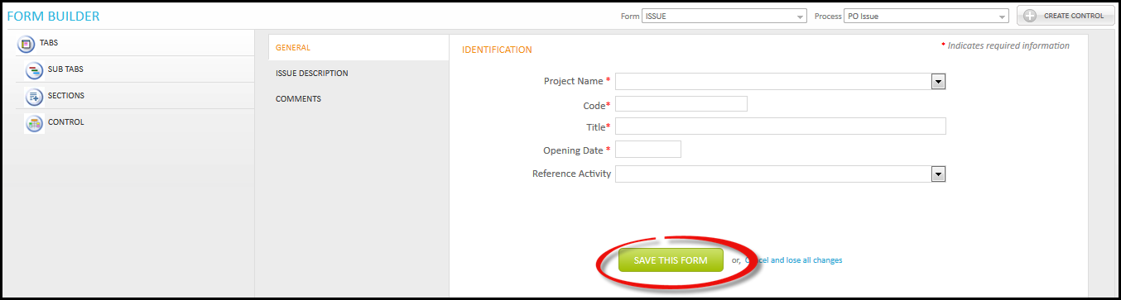

1. A new version will be created for this Form.

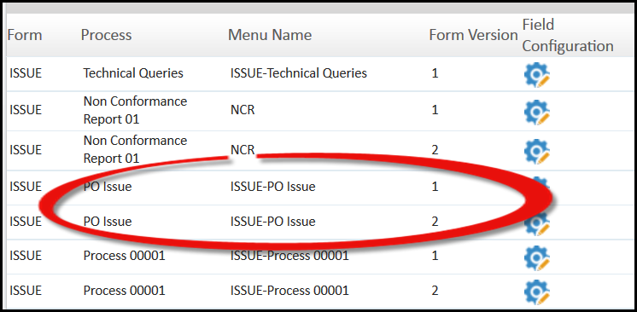

With the creation of version for Form, workflow for this new version is also created under Workflow Designer. Workflow created will be same as for version 1, until you change it.

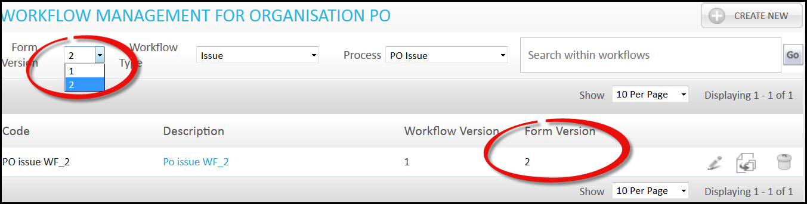

### Field Configuration for version

Field Configuration is used to define the fields available in particular form. You can change the name of field from its standard name with the help of Field Configuration option available here.

1. Click ***Field Configuration*** of version 2.

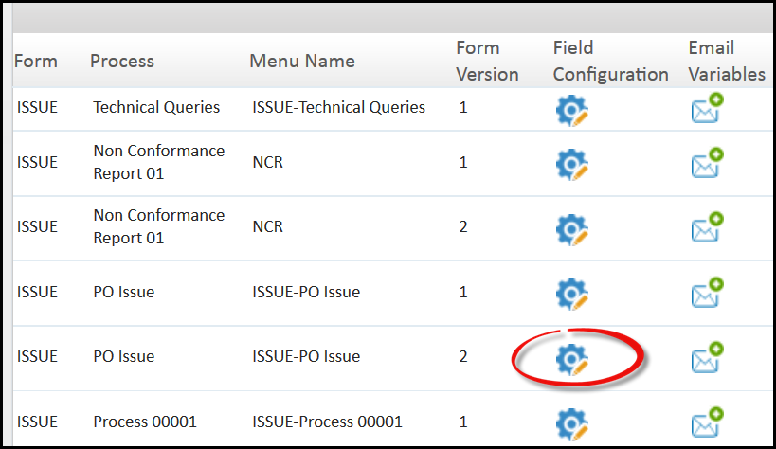

1. You will be directed to Field Configuration page. Here user can edit the name of Field available in particular Form. Click  and make changes, then click.

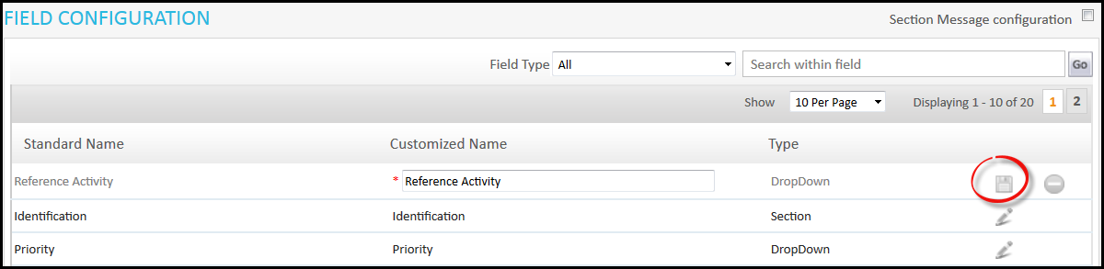

### Email Variables for version

This is used to define the Variables that can be used in Email. These variables will be available while sending mail and can be used in messages for references.

1. Click ***Email Variables*** for version 2.

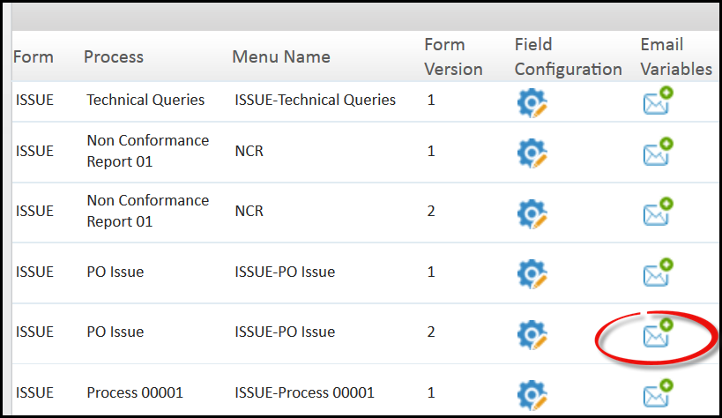

1. You will be directed to Email Variable page, where you can select fields from the available list that will be used in Emails. Then click ***Apply*** to save data and continue working or ***Save*** to save and close.

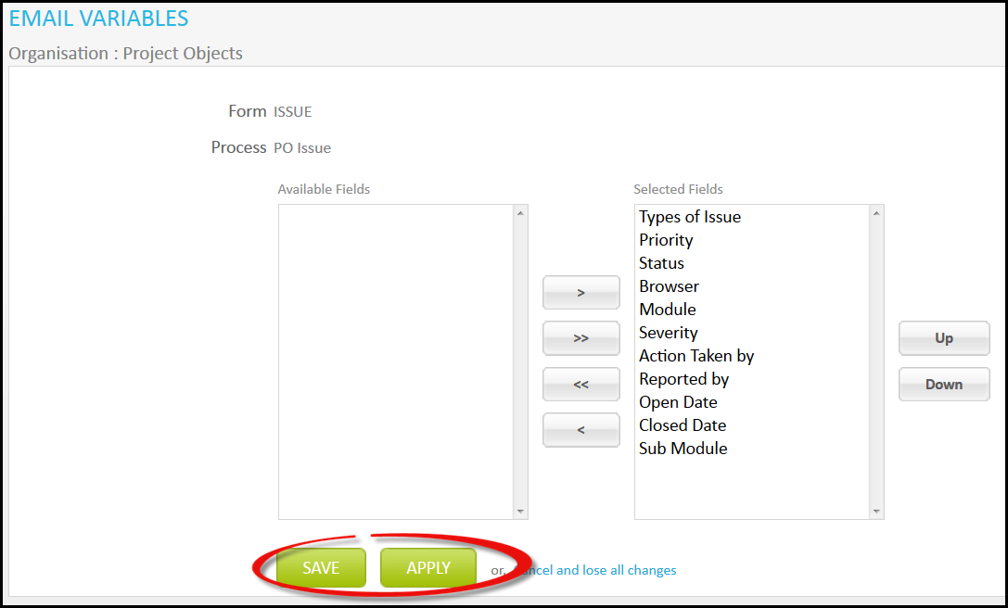

### Register Fields for version

Here user can define the Fields that will appear as heading on listing page of issues (“POIssue” that we have created, under Team Space). After creation of new version, a new option will appear with name ***ADD Fields to Single Register.***

### Add Fields to Register

Here only the fields which are avaialble will appear in the form of that particular version.

* 1. Click ***ADD Fields to Register*** of vesion 2.

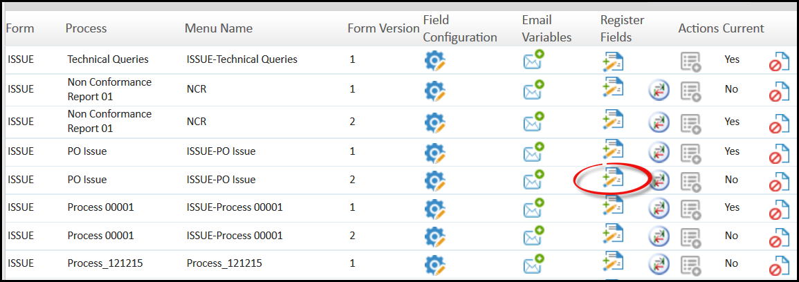

* 1. You will be directed to Register Fields; here you can select the fields. Then click ***Apply*** to save data and continue working or ***Save*** to save and close.

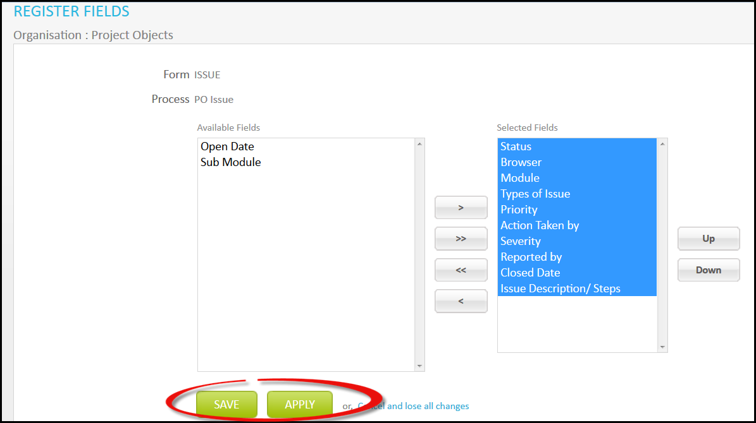

### Add Fields to Single Register

After creation of form version a new option appears i.e. Add Fields To Single Register. Under this, fields from both version are imported. All the fields that are available in both the version are shown here (common fields shown only once). Follow the below steps.

1. Click ***Add Fields to Single Regiter*** of version 2.

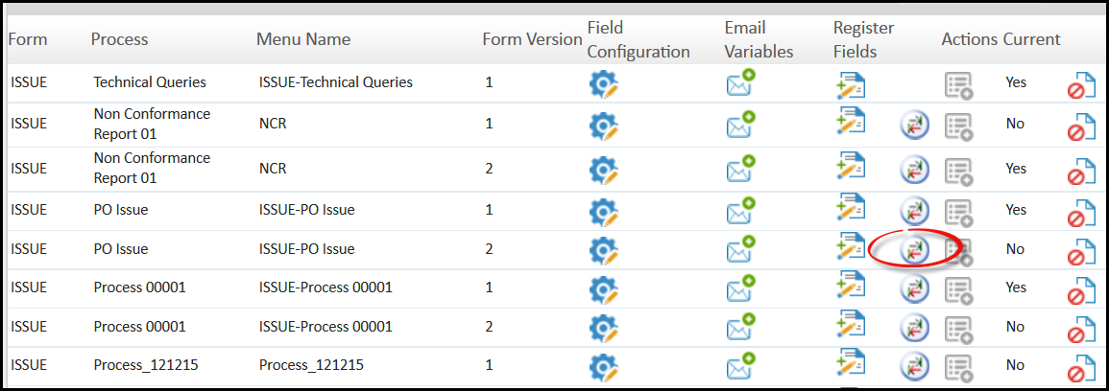

1. You will be directed to Single Register Fields page. Select the fields and click ***Save*** to save.

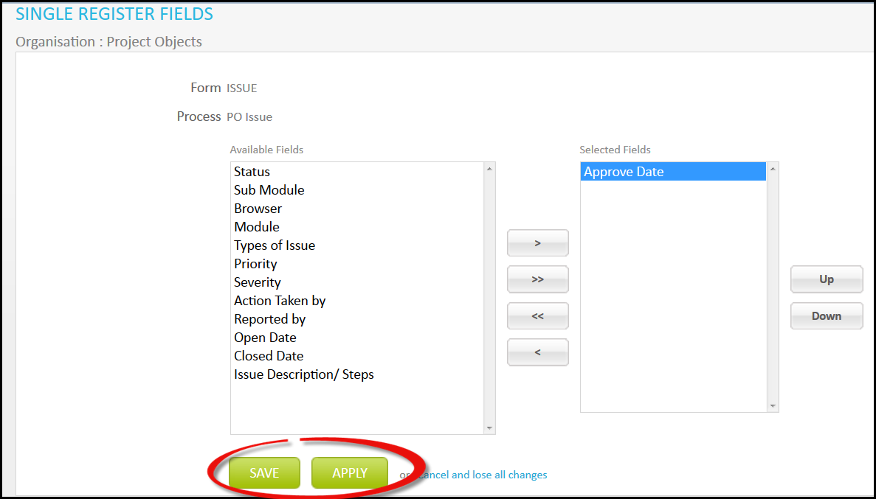

1. Now we will see the effect on issue page for which we have done this. Go to Team Space and select the issue page.

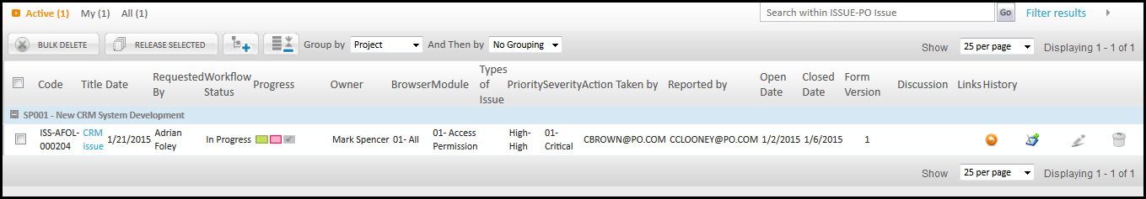

1. Now select Form Version and click ***Single Register.*** It will show common fields and those which we have selected above.

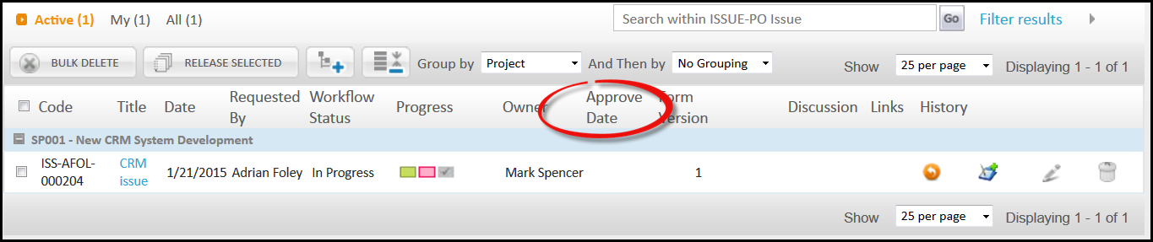

You can see above, Approve Date field is coming on Selecting Single Register Fields, which we have selected under single register option.

### Action for version 2

Here you can define mandatory and bulk edit fields.

1. Click ***Actions***.

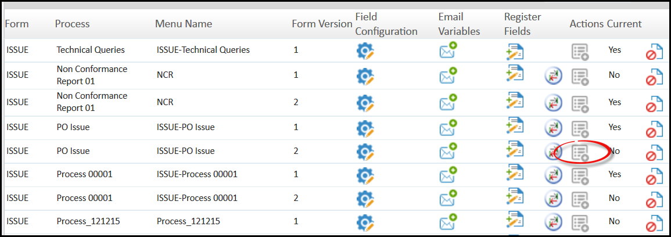

1. You will be directed to Customize Association page where you can define the properties. Mandatory field cannot be selected as bulk edit. Click ***Apply*** to save data and continue working or ***Save*** to save and close.

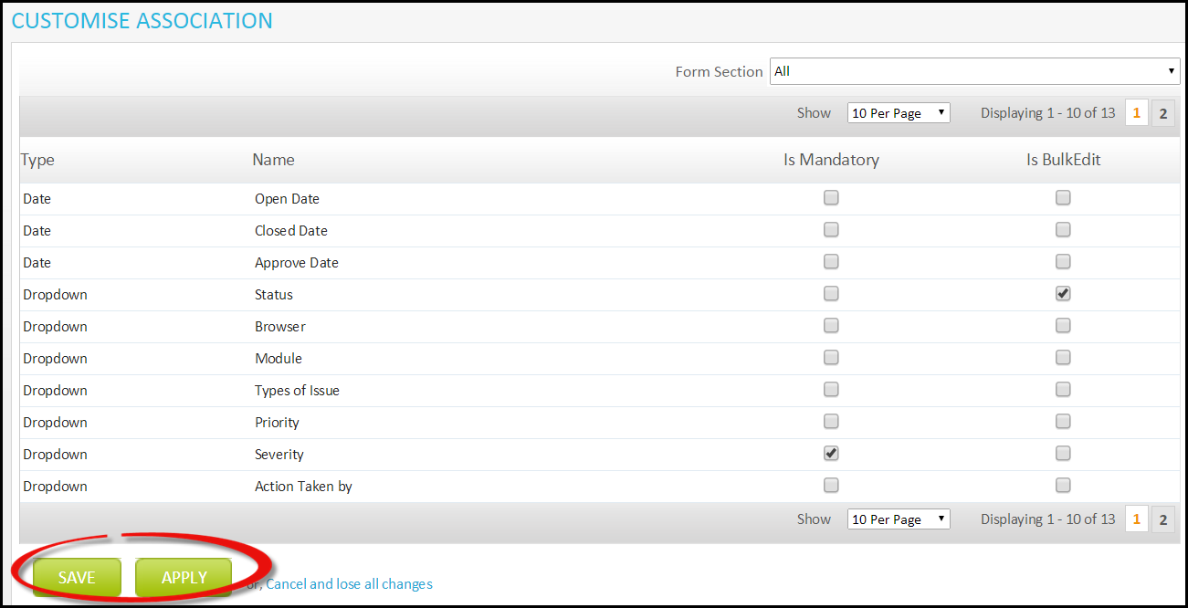

### Process Settings

If there are more than one form versions, then user need to define a current form that will be used in Team Space. Therefore, to select current form for the application, the user needs to use Process Settings option.

1. Select ***Process Setting.***

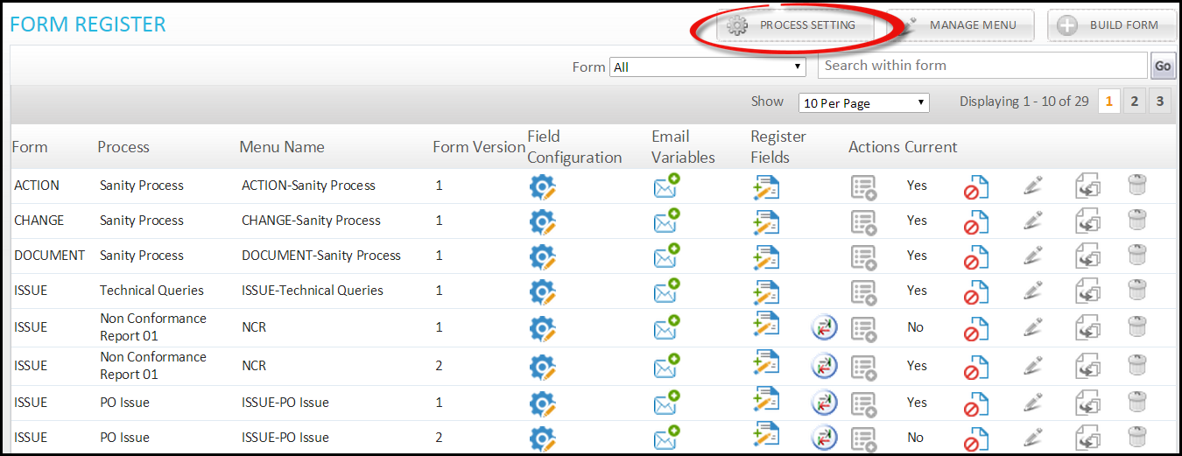

1. You will be directed to Process Setting page, here you can select the Version that you want to make as current. Here different versions will be available for selection. Only one version at a time can be made current. Click , check under current column and click.

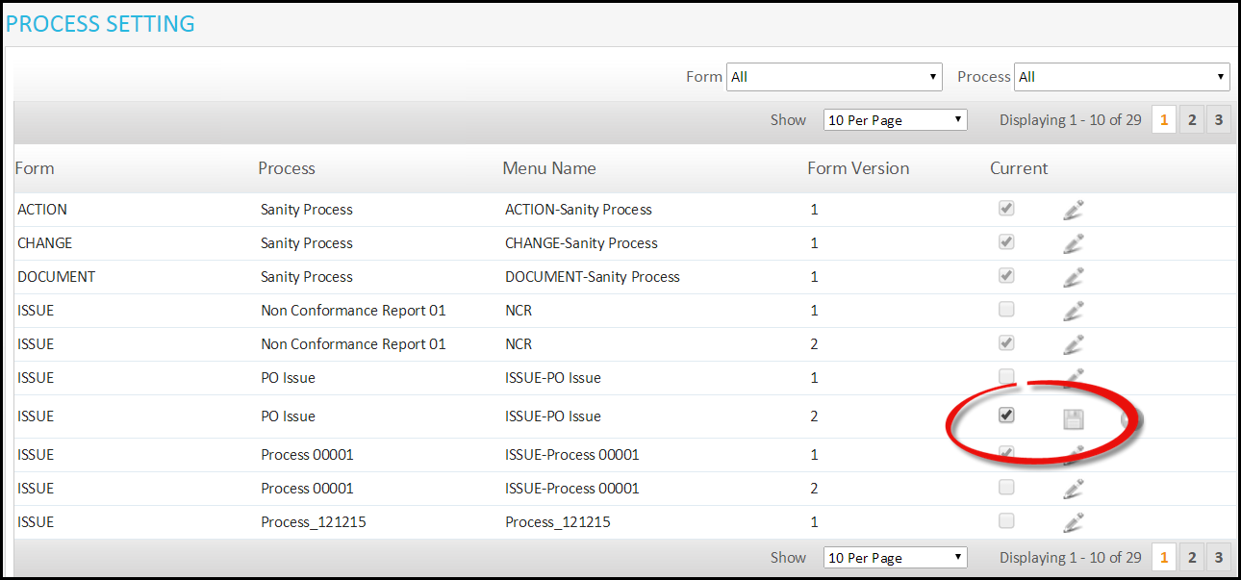

Even After making a form version as current, a process cannot be executed till we associate workflow with project for Form version 2. To do that user needs to go to Workflow Association and do the following steps.

1. Select Form Version.

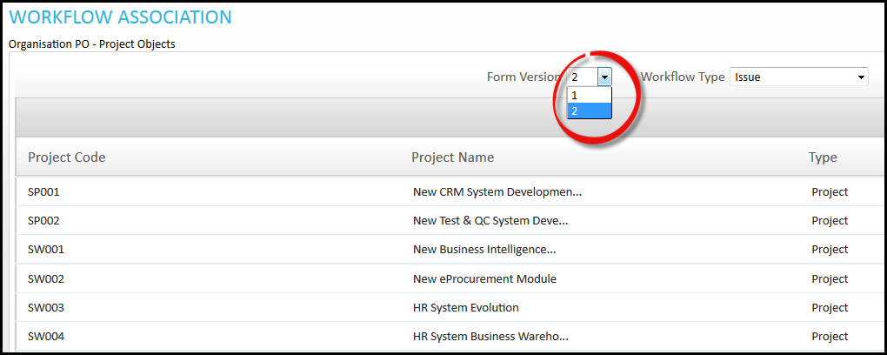

1. Now click on  adjacent to project for which you want to associate.

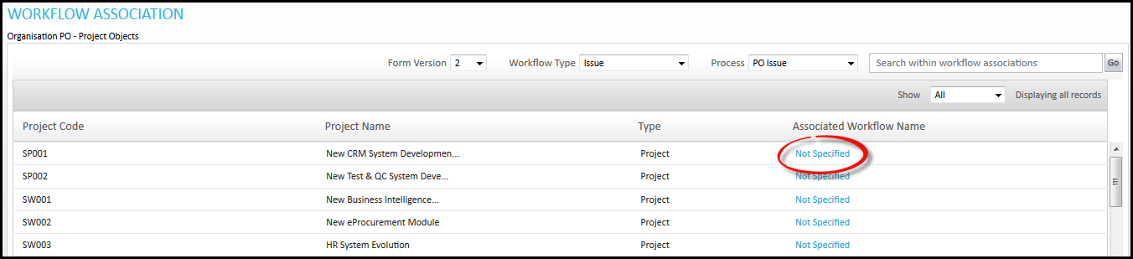

1. You will be directed to Workflow Setting page, click 

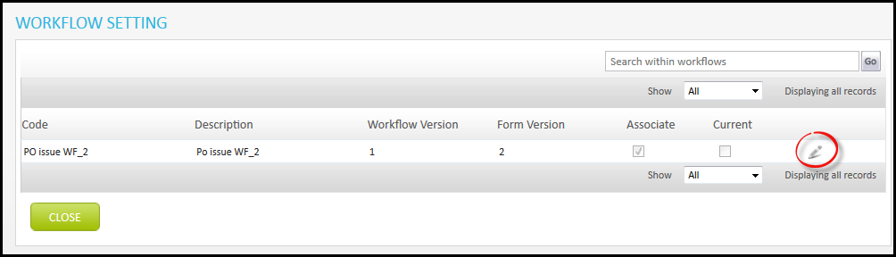

1. Check Workflow as current and click 

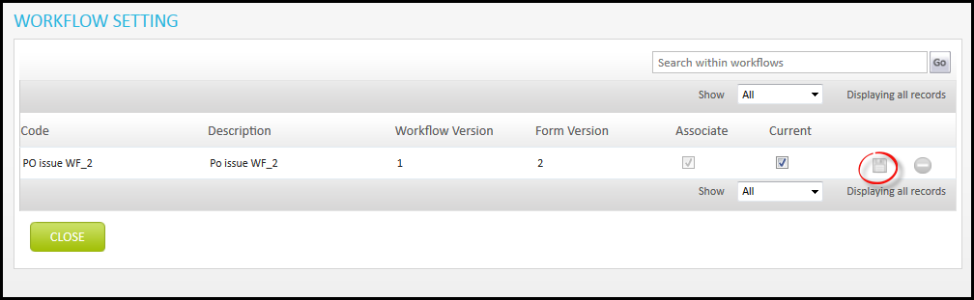

1. Workflow will be associated for form 2 on project.

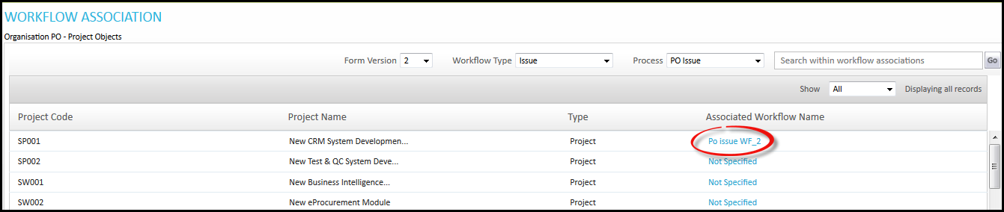

### Manage Menu for version 2

Here user can change the name of created Form. This name will be shown under Team Space.

1. Click ***Manage Menu***

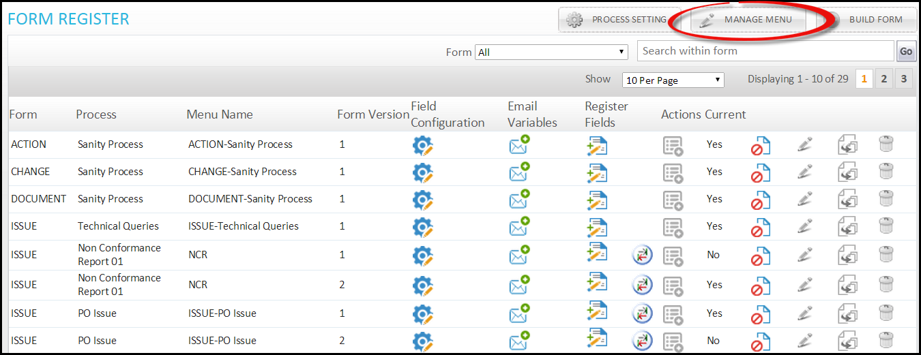

1. You will be directed to Manage Menu page; here you can change the name of your Form. Click, change the name and click.

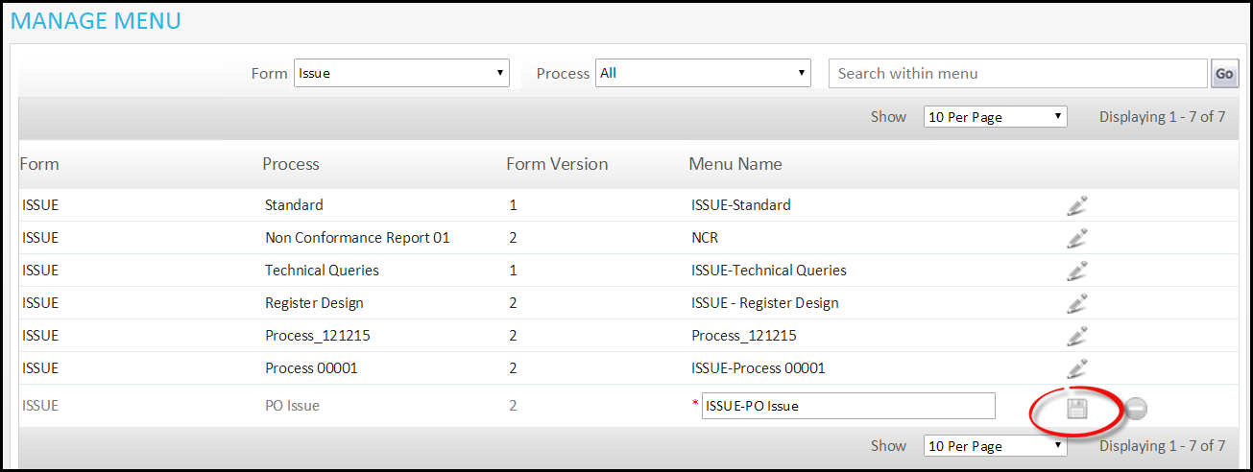

## Workflow Version

Workflow version is used to create different version of workflow. Here we will discuss how version can be created and its functioning.

### Create workflow version

1. Click ***Workflow Designer***.

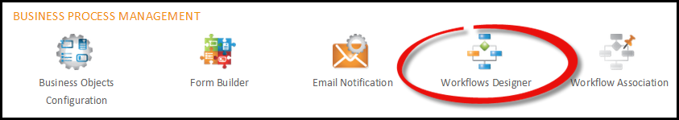

1. After creating object, under workflow section, new option appears i.e. ***Save Version.*** You can change the workflow and Click ***Save.***

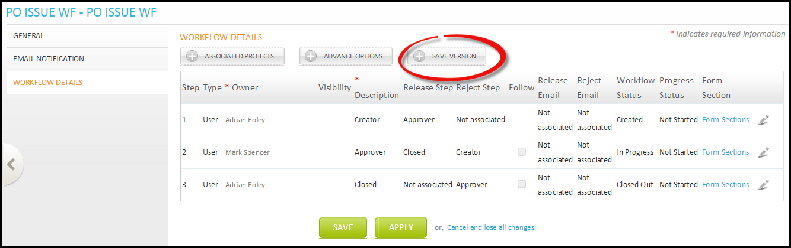

1. New version will be saved.

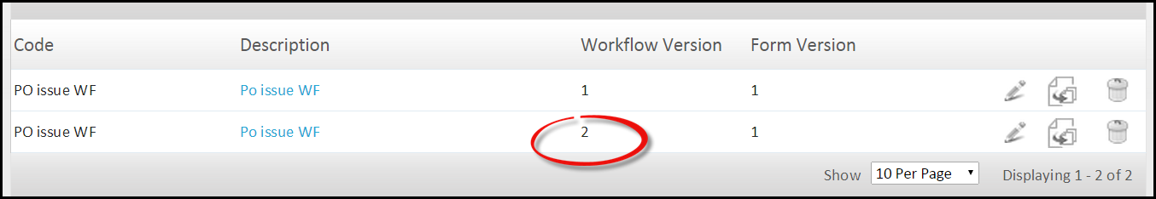

Chapter 9

Version Association with Workflow

# Version Association with Projects

Here we will discuss how user can associate different versions with projects.

1. Click ***Workflow Association***.

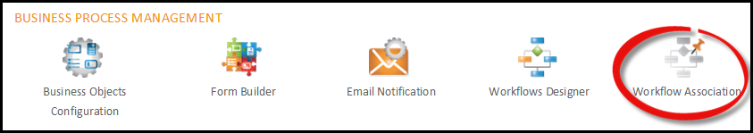

1. You will be directed to Workflow Association page, select form version, and click  to change the version.

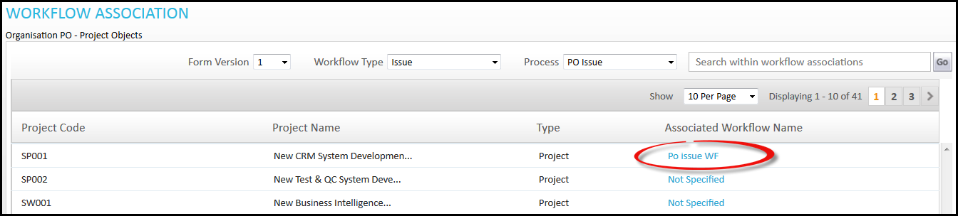

1. You will be directed to Workflow Setting page.

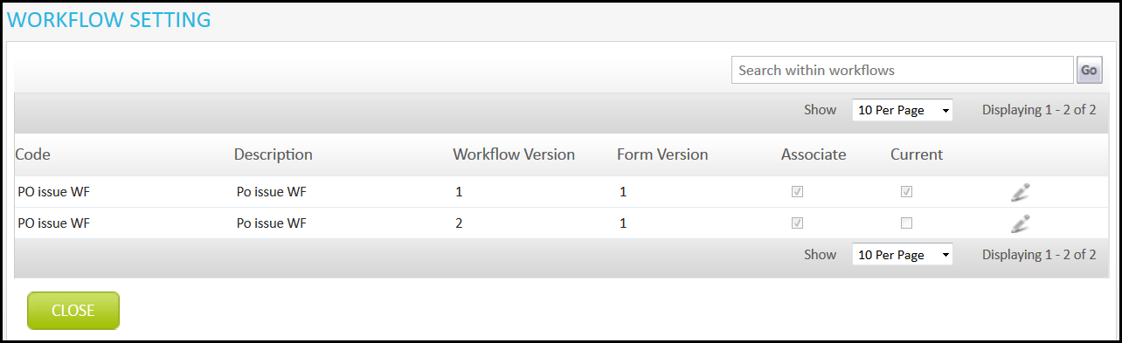

1. Click  to change the version and click to save.

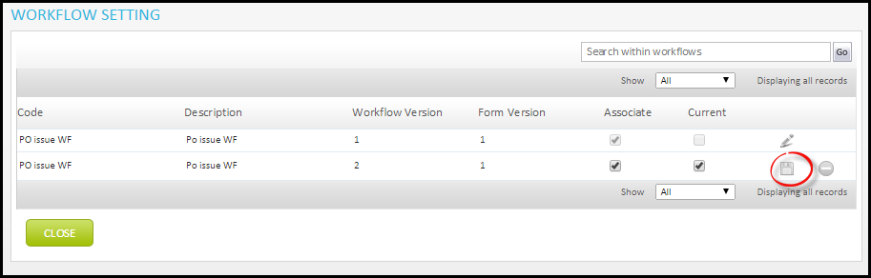

Chapter 10

Multiple Users in Workflow

# Multiple User in Workflow

A new step owner has been added in PO application. Before this, only user, group or role can be made step owmer, but now we will also get an option of Multiple. Multiple means, you can enroll as many user, group or role in one step. Follow below steps to perform this.

1. Goto workflow section, while inserting a step, select Multiple in type.

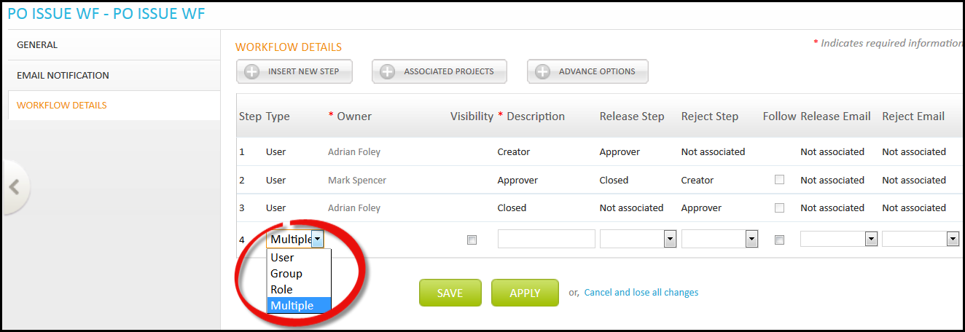

With this, visibility check box will appear. You can check visibility section over here that appears while creating objects to select the users whom you want give the visibility for that particular object.

1. Fill the required information and click  and then ***Apply***.

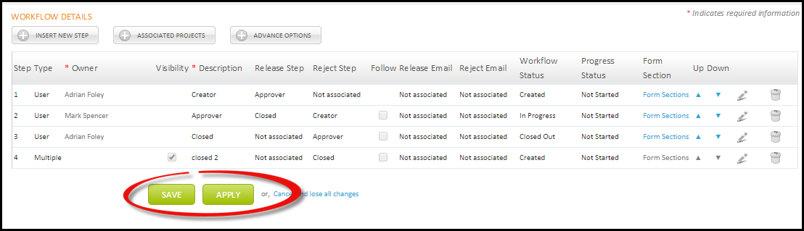

1. New option will appear to select Step Owners. Click ***Step Owners***.

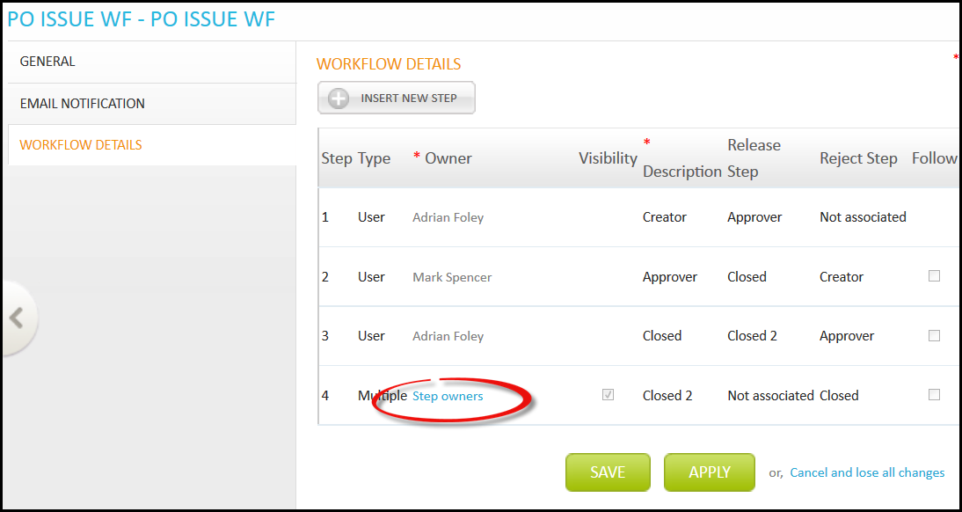

1. You will be directed to step owner association page. Select owners and click ***Save***.

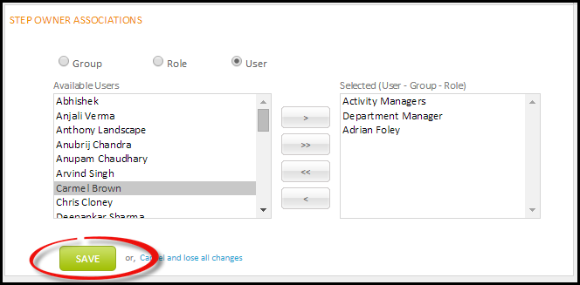

Only the above selected owner will be able to see the object.

## Visibility

Visibillty section appears while creating new object. Select the owner whom you want to give visibility for an object.

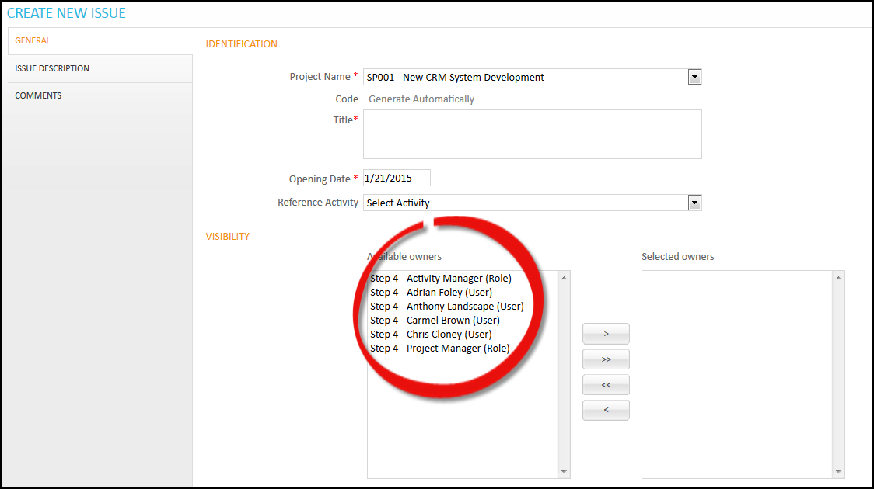

Scope for Future Work

Advantages

# Scope for Future Work

There is always a scope for improvement. With the help of our Resaearch and Development team, we have developed seven versions till date and now we have released the eights version of our PO application. With every version, you can easily find the changes and the upgradations which have been based on the studies and requirements requisite of our clients. Our Research and Analysis wing always strive for the improvement of the application to make it more user oriented and friendly. Portfolio and Project Management is not a defined methodology, it changes with the work scenario and the technological advancement. Now we have already started working on the future roadmap of our application with more of the updated features.

# Advantages

* Customization of Process.
* User can build form for different objects differently.
* User can apply properties and setting according to his requirements.
* Multiple User option in Workflow, gives advantages to add as many step owner on same step.
* Version definition allow user to use different versions as required.
* Advance Option allows user to define more settings for step owners in workflow.
* Email Variables allows user to define variable for Email Notification.
* Registered fields added in this version is also very important and usefull for the user.